

## MINI PROJECT REPORT

*On*

### CIVICBRIDGE-COMMUNITY COMPLAINT REPORTING AND ESCALATION SYSTEM

*Submitted in partial fulfilment for the award of degree*

*Of*

#### Master of Computer Applications

*By*

### ATHIRA ANIL (MLM24MCA-2022)

Under the Guidance of

### Mr. ELDHOSE K PAUL

(Associate Professor, Dept. of Computer Applications)



## DEPARTMENT OF COMPUTER APPLICATIONS MANGALAM COLLEGE OF ENGINEERING, ETTUMANOOR

***(Affiliated to APJ Abdul Kalam Technological University)***

## OCTOBER 2025

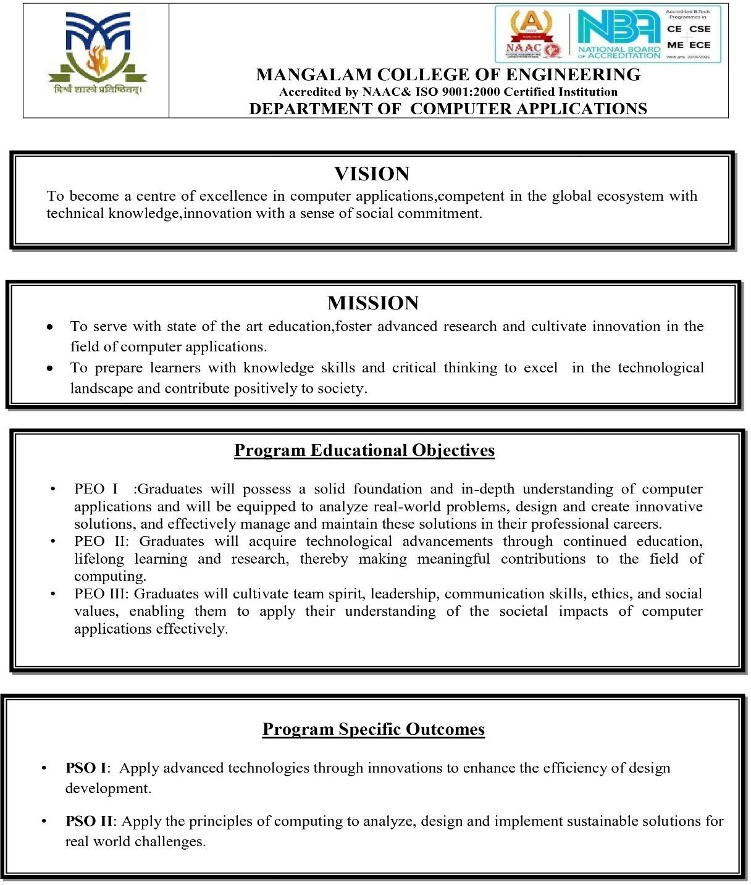

**MAPPING OF PO-PSO-SDG**

###### MAPPING WITH PROGRAM OUTCOMES (POs):

|  |  |  |
| --- | --- | --- |
| **SL.NO** | **POs ADDRESSED** | **RELEVANCE TO PROJECT** |
| 1. | **PO1 – Engineering Knowledge** | The project applies knowledge of **computer science, web technologies, database systems, and software engineering** to design and develop a functional web-based platform for managing civic complaints. It integrates both theoretical and practical computing concepts to  solve real-world problems efficiently. |
| 2. | **PO2 Problem Analysis** | The project identifies and analyzes issues in civic infrastructure such as garbage disposal, potholes, and faulty streetlights. It formulates a systematic solution that enables citizens to report problems and authorities to resolve them  effectively using digital means. |
| 3. | **PO3 – Design/Development of Solutions** | CivicBridge is designed as a complete web- based system with modules for **user login, officer panel, complaint submission, escalation, and notifications**. The system design ensures usability, reliability, and social relevance while addressing public safety and  environmental concerns. |
| 4. | **PO5– Modern Tool Usage** | The project utilizes modern tools such as **Python (Django framework), HTML, CSS, JavaScript, and database management systems** for developing and testing the application. These technologies enhance productivity and provide a scalable and efficient solution. |

|  |  |  |
| --- | --- | --- |
| 5. | **PO6 – The Engineer and Society** | The system directly benefits society by providing a **digital platform for citizen engagement** in civic problem-solving. It promotes accountability, transparency, and responsiveness in governance, contributing to  better community living standards. |
| 6. | **PO7 – Environment and Sustainability** | By enabling digital complaint submission and reducing paperwork, the project supports **eco- friendly, sustainable practices**. It also contributes to environmental improvement by facilitating faster resolution of public sanitation  and infrastructure issues. |
| 7. | **PO9 – Individual and Team Work** | The development of CivicBridge involved **collaboration, coordination, and role-based tasks**, demonstrating teamwork and leadership in a multidisciplinary project environment. |
| 8. | **PO10 – Communication** | Throughout the project, effective communication was maintained through documentation, diagrams, and presentations. The interface also facilitates clear communication between users and officers  through notifications and status updates. |
| 9. | **PO11– Project Management and Finance** | The project includes planning, task scheduling, and resource management during development. Basic cost-effective solutions were considered while selecting hosting and technology tools,  aligning with principles of project management. |
| 10. | **PO12 – Lifelong Learning** | CivicBridge explored new frameworks beyond the curriculum, promoting continuous learning and adaptation to emerging web technologies. |

**LIST OF PROGRAM OUTCOMES (POs):**

**PO1 – Engineering Knowledge**: Apply knowledge of mathematics, science, engineering fundamentals, and an engineering specialization to solve complex engineering problems.

**PO2 – Problem Analysis**: Identify, formulate, research literature, and analyze complex engineering problems reaching substantiated conclusions using first principles of mathematics, natural sciences, and engineering sciences.

**PO3 – Design/Development of Solutions**: Design solutions for complex engineering problems and design systems, components, or processes that meet specified needs with appropriate consideration for public health and safety, cultural, societal, and environmental considerations.

**PO4 – Conduct Investigations of Complex Problems**: Use research-based knowledge and research methods including design of experiments, analysis, and interpretation of data, and synthesis of information to provide valid conclusions.

**PO5– Modern Tool Usage**: Create, select, and apply appropriate techniques, resources, and modern engineering and IT tools, including prediction and modeling, to complex engineering activities with an understanding of the limitations.

**PO6 – The Engineer and Society**: Apply reasoning informed by contextual knowledge to assess societal, health, safety, legal, and cultural issues and the consequent responsibilities relevant to professional engineering practice.

**PO7 – Environment and Sustainability**: Understand the impact of professional engineering solutions in societal and environmental contexts and demonstrate knowledge of, and need for sustainable development.

**PO8 – Ethics**: Apply ethical principles and commit to professional ethics and responsibilities and norms of engineering practice.

**PO9 – Individual and Team Work**: Function effectively as an individual, and as a member or leader in diverse teams, and in multidisciplinary settings.

**PO10 – Communication**: Communicate effectively on complex engineering activities with the engineering community and with society at large, such as being able to comprehend and write effective reports and design documentation, make effective presentations, and give and receive clear instructions.

**PO11 –Project Management and Finance**: Demonstrate knowledge and understanding of engineering and management principles and apply these to one’s own work, as a member and leader in a team, to manage projects and in multidisciplinary environments.

**PO12 – Lifelong Learning**: Recognize the need for, and have the ability to engage in independent and life-long learning in the broadest context of technological change.

###### MAPPING WITH PROGRAM SPECIFIC OUTCOMES (PSOs):

|  |  |  |
| --- | --- | --- |
| **SL.NO** | **PSOs ADDRESSED** | **RELEVANCE TO PROJECT** |
| 1. | **PSO 1** | The project “CivicBridge” reflects PSO 1 by applying advanced web technologies and innovative design methods to enhance the efficiency of system development. The integration of Django framework, structured data flow, and user-centered interface demonstrates how technological innovation can simplify and optimize real-  world problem-solving in civic management. |
| 2. | **PSO 2** | The project “CivicBridge” demonstrates PSO 2 by utilizing core computing principles to analyze community- level challenges and develop a sustainable, technology- driven solution. Through systematic design, database management, and web implementation, the project contributes to improving civic infrastructure and supports environmental sustainability by promoting paperless  complaint management. |

**LIST OF PROGRAM SPECIFIC OUTCOMES (PSOs):**

**PSO 1**: Apply advanced technologies through innovations to enhance the efficiency of design development.

**PSO 2**: Apply the principles of computing to analyze, design and implement sustainable solutions for real world challenges.

1. **MAPPING WITH SUSTAINABLE DEVELOPMENT GOALS (SDGs):**

|  |  |  |
| --- | --- | --- |
| **SDG NO** | **SDGs ADDRESSED** | **RELEVANCE TO PROJECT** |
| **SDG6** | **Clean Water and Sanitation** | CivicBridge allows citizens to report sanitation- related issues like garbage accumulation, drainage blockages, or water stagnation. By enabling quick response from authorities, the system helps maintain clean surroundings and  supports public hygiene. |
| **SDG9** | **Industry, Innovation, and Infrastructure** | CivicBridge leverages digital innovation to enhance urban infrastructure management by efficiently addressing civic complaints on roads, lighting, and waste, promoting smarter city  development. |
| **SDG11** | **Sustainable Cities and Communities**- | CivicBridge directly contributes to building **cleaner, safer, and more responsive cities** by connecting citizens and municipal authorities. It encourages civic participation, transparency, and  sustainable community development. |
| **SDG13** | **Climate Action** | By addressing waste management, pollution, and environmental cleanliness through timely complaint resolution, the project indirectly contributes to reducing urban pollution and  supporting climate-friendly urban practices. |
| **SDG16** | **Peace, Justice, and Strong Institutions** | CivicBridge enhances institutional accountability through a transparent complaint system, ensuring systematic grievance resolution and fostering  trust between citizens and authorities. |
| **SDG17** | **Partnerships for the Goals** | The platform fosters **collaboration between citizens, officers, and local government bodies**, aligning with the spirit of partnership for  sustainable community management. |

**SUSTAINABLE DEVLOPMENT GOALS (SDGs):**

**SDG 1 – No Poverty**-End poverty in all its forms everywhere.

**SDG 2 – Zero Hunger**-End hunger, achieve food security and improved nutrition, and promote sustainable agriculture.

**SDG 3 – Good Health and Well-Being**-Ensure healthy lives and promote well-being for all at all ages.

**SDG 4 – Quality Education**-Ensure inclusive and equitable quality education and promote lifelong learning opportunities for all.

**SDG 5 – Gender Equality**-Achieve gender equality and empower all women and girls.

**SDG 6 – Clean Water and Sanitation**-Ensure availability and sustainable management of water and sanitation for all.

**SDG 7 – Affordable and Clean Energy**-Ensure access to affordable, reliable, sustainable, and modern energy for all.

**SDG 8 – Decent Work and Economic Growth**-Promote sustained, inclusive, and sustainable economic growth, full and productive employment, and decent work for all.

**SDG 9 – Industry, Innovation, and Infrastructure**-Build resilient infrastructure, promote inclusive and sustainable industrialization, and foster innovation.

**SDG 10 – Reduced Inequality**-Reduce inequality within and among countries.

**SDG 11 – Sustainable Cities and Communities**-Make cities and human settlements inclusive, safe, resilient, and sustainable.

**SDG 12 – Responsible Consumption and Production**-Ensure sustainable consumption and production patterns.

**SDG 13 – Climate Action**-Take urgent action to combat climate change and its impacts.

**SDG 14 – Life Below Water**-Conserve and sustainably use the oceans, seas, and marine resources. **SDG 15 – Life on Land** -Protect, restore, and promote sustainable use of terrestrial ecosystems, manage forests sustainably, combat desertification, halt and reverse land degradation, and halt biodiversity loss.

**SDG 16 – Peace, Justice, and Strong Institutions**- Promote peaceful and inclusive societies, provide access to justice for all, and build effective, accountable, and inclusive institutions.

**SDG 17 – Partnerships for the Goals** -Strengthen the means of implementation and revitalize the global partnership for sustainable development.

### MANGALAM COLLEGE OF ENGINEERING, ETTUMANOOR DEPARTMENT OF COMPUTER APPLICATIONS

**OCTOBER 2025**



#### DECLARARTION

*I hereby certify that the work which is being presented in the project entitled “CivicBridge- Community complaint Reporting and Escalation System” submitted in the* ***DEPARTMENT OF COMPUTER APPLICATIONS*** *is an authentic record of my own work carried under the supervision of* ***Mr. ELDHOSE K PAUL, ASSOCIATE PROFESSOR****, Department of Computer Applications, Mangalam College of Engineering. This study has not been submitted to any other institution or university for the award of any other degree. This report has been checked for plagiarism by the college and the similarity index is within permissible limits set by the college.*

*Date: Name & Signature of Student*

*Place:*

### MANGALAM COLLEGE OF ENGINEERING, ETTUMANOOR DEPARTMENT OF COMPUTER APPLICATIONS

**OCTOBER 2025**



#### CERTIFICATE

*This is to certify that the Project titled* ***“CivicBridge-Community complaint reporting and escalation system”*** *is the bona fide record of the work done by* ***ATHIRA ANIL (MLM24MCA-2022****) of Master of computer Applications towards the partial fulfilment of the requirement for the award of* ***MASTER OF COMPUTER APPLICATIONS by APJ ABDUL KALAM TECHNOLOGICAL***

***UNIVERSITY****, during the academic year 2025-26.*

**Internal Examiner**

**Project Coordinator Ms. Banu Sumayya S Assistant Professor**

**Department of Computer Applications**

**Project Guide**

**Mr. ELDHOSE K PAUL**

**Associate Professor**

**Department Of Computer Applications**

**Head of the Department Ms. Divya S B Associate Professor**

**Department of Computer Applications**

### ACKNOWLEDGEMENT

I am greatly indebted to the authorities of Mangalam College of Engineering for providing the necessary facilities to successfully complete my Project on the topic “CivicBridge-Community complaint reporting and escalation system”.

I express my sincere thanks to **Dr. Vinodh P Vijayan**, Principal, Mangalam College of Engineering for providing the facilities to complete my Project successfully.

I thank and express my solicit gratitude to **Ms. Divya S B,** HOD, Department of Computer Applications, Mangalam College of Engineering, for her invaluable help and support which helped me a lot in successfully completing this Project work.

I express my gratitude to my Internal Guide, **Mr. Eldhose K Paul**, Associate professor, Department of Computer Applications for the suggestions and encouragement which helped in the successful completion of my Project.

Furthermore, I would like to acknowledge with much appreciation the crucial role of the faculties especially Project coordinator, **Ms. Banu Sumayya S**, Department of Computer Applications, Mangalam College of Engineering, who gave the permission to use all the required equipment and the necessary resources to complete the presentation & report.

Finally, I would like to express my heartfelt thanks to my parents who were very supportive both financially and mentally and for their encouragement to achieve my goal.

**ATHIRA ANIL (MLM24MCA-2022)**

### ABSTRACT

The CivicBridge project is a web-based application designed to improve the communication and problem-resolution process between citizens and local government authorities. Often, addressing civic issues such as road damage, waste disposal problems, streetlight malfunctions, or water supply interruptions involves slow and inefficient manual systems. CivicBridge provides a centralized online platform where citizens can conveniently register their complaints and monitor the progress of their resolution.

The system is developed using the Django framework in Python for the backend, and HTML, CSS, and JavaScript for the frontend. Once a complaint is registered, it is automatically categorized and assigned to the concerned officer based on the issue type and location. Officers can update the complaint status as they process it. If an officer is unable to handle a complaint, they can use the “Escalate” button to forward it to a higher-level officer for further action. The system also incorporates email notifications to inform users about complaint updates, ensuring smooth and transparent communication.

By offering a structured, user-friendly, and efficient platform, CivicBridge promotes accountability, enhances transparency, and simplifies the grievance redressal process. This project contributes to the development of smart governance by bridging the gap between citizens and administrative authorities.

|  |  |
| --- | --- |
| **Mapping with Sustainable Development Goals (Mention the Goal)** | SDG 9 – Industry Innovation and Infrastructure  SDG 6 – Clean Water and Sanitation  SDG 11 –Sustainable Cities and Communities  SDG 13 – Climate Action  SDG 16 – Peace, Justice, and Strong Institutions SDG 17 – Partnerships for the Goals |

**TABLE OF CONTENTS**

|  |  |  |
| --- | --- | --- |
| **CHAPTER NO.** | **TITLE** | **PAGE NO.** |
|  | **List of FIGURES** | **I** |
|  | **List of ABBREVATIONS** | **II** |
| **1** | **INTRODUCTION** | **1** |
|  | 1.1 Background | 1 |
|  | 1.2 Introduction | 2 |
|  | 1.3 Problem Statement | 3 |
|  | 1.4 Motivation | 4 |
|  | 1.5 Scope | 5 |
| **2** | **LITERATURE REVIEW** | **6** |
|  | 2.1 Public Online Complaint Registration and Management System | 6 |
|  | 2.2 iGRAM: Online Grievance Redressal at IGNOU | 7 |
|  | 2.3 RE-GrievanceAssist | 8 |
|  | 2.4 Web-Based Complaint System | 10 |
|  | 2.5 Online Community Aspiration Services | 11 |
|  | 2.6 Blockchain & AI Grievance System | 12 |
|  | 2.7 Complaint Registration App for E-Governance | 14 |
|  | 2.8 Web-Based Integrated Student Complaint System | 15 |
|  | 2.9 Complaint Monitoring System Using Android in Iraq | 16 |
|  | 2.10 Web-Based Complaints Service Information System at Dewantara District Office | 17 |
| **3** | **PROPOSED SYSTEM** | **19** |

1. METHODOLOGY 22
   1. Requirement Analysis and System Study 22
   2. System Design and Architecture 23
   3. Development and Module Implementation 24
   4. Workflow Process 25
   5. Testing and Validation 26
   6. Deployment and Maintenance 26
   7. Security and Ethical Considerations 26
   8. Summary of Methodology 27
2. SYSTEM ARCHITECTURE 28
   1. Architectural Overview 29
   2. Architectural Layers 29
   3. System Workflow 30
   4. Architectural Diagram (Description) 31
   5. Security and Communication 31
   6. Advantages of the System Architecture 31
3. MODULES 32
   1. User & Officer Login Module 32
   2. Complaint Submission Module 33
   3. Officer Panel Module 34
   4. Escalation System Module 35
   5. Notification System Module 36
   6. Approve Officer Panel Module 36
4. DIAGRAMS 37
   1. DATA FLOW DIAGRAMS(DFD) 37
      1. level 0 37
      2. level 1 admin 38
      3. level 1 citizen 39
      4. level1 officer 41
   2. USE CASE DIAGRAM 42
   3. STATE DIAGRAM 43
   4. ENTITY-RELATIONSHIP DIAGRAM(ER) 45
   5. CLASS DIAGRAM 46
5. TESTING 47
   1. Data Collection and Preparation 47
   2. Functional Testing 48
   3. Performance and Load Testing 49
   4. Security and Privacy Testing 49
   5. User Acceptance Testing (UAT) 50
   6. Issue Tracking and Resolution 50
   7. Deployment and Monitoring Testing 50
   8. Conclusion 51
6. ADVANTAGES AND DISADVANTAGES 52
   1. Advantages 52
   2. Disadvantages 53
7. RESULTS 54
   1. Complaint Submission Analysis 54
   2. Officer Panel Analysis 55
   3. Escalation System Analysis 55
   4. Notification System Analysis 56
   5. System Performance and Reliability Analysis 56
   6. Conclusion 56
8. CONCLUSION & FUTURE SCOPE 57
   1. CONCLUSION 57
   2. FUTURE SCOPE 58

APPENDICES 59

REFERENCES 63

## LIST OF FIGURES

|  |  |  |
| --- | --- | --- |
| **FIGURE NO.** | **TITLE** | **PAGE NO.** |
| 5.1 | System Architecture | 28 |
| 6.1 | User Login Module | 32 |
| 6.2 | Officer Login Module | 33 |
| 6.3 | Complaint Submission Module | 34 |
| 6.4 | Officer Panel Module | 35 |
| 6.5 | Escalation System Module | 35 |
| 6.6 | Notification System Module | 36 |
| 6.7 | Approve Officer Panel Module | 36 |
| 7.1 | Level 0 | 37 |
| 7.2 | Level 1 admin | 38 |
| 7..3 | Level 1 citizen | 40 |
| 7.4 | Level 1 officer | 41 |
| 7.5 | Use case Diagram | 43 |
| 7.6 | State Diagram | 44 |
| 7.7 | ER Diagram | 45 |
| 7.8 | Class Diagram | 46 |
| 10.1 | User Dashboard | 54 |

* 1. Officer Panel Analysis 55

I

## LIST OF ABBREVATIONS

### ABBREVIATION FULL FORM

DFD Data Flow Diagram

ER Entity-Relationship Diagram

HTML HyperText Markup Language

CSS Cascading Style Sheets

MySQL My Structured Query

Language

SQLite Structured Query Language –

Lightweight

SMTP Simple Mail Transfer

Protocol

HTTP HyperText Transfer Protocol

NLP Natural Language Processing

AI Artificial Intelligence

## II

* 1. **Background**

## CHAPTER 1

### INTRODUCTION

In most communities, citizens encounter a variety of civic issues in their daily lives, such as damaged or poorly maintained roads, malfunctioning streetlights, water leakage, blocked drainage systems, and uncollected waste. These problems, although common, can significantly affect the quality of life and the smooth functioning of urban areas. Traditionally, citizens have been required to visit government offices in person or contact officials directly to report such issues. These manual and time-consuming procedures often lead to delays, miscommunication, and lack of proper follow-up. In many cases, complaints are lost, ignored, or addressed only after long waiting periods. This lack of efficiency and accountability in grievance handling reduces public trust and discourages citizens from participating actively in civic improvement efforts.

With the rapid growth of technology and the increasing adoption of e-governance, governments and local authorities are now exploring digital solutions to modernize public service delivery. There is a growing need for platforms that can make the grievance reporting process more efficient, transparent, and citizen-friendly. The CivicBridge project was developed in response to this need. It aims to bridge the communication gap between citizens and government departments by offering a centralized online platform for complaint registration and management. Through this web-based system, users can easily submit complaints about civic issues, attach images for clarity, and track the status of their complaints in real time. This reduces the need for physical visits or repeated follow- ups, saving time and effort for both citizens and officials.

In addition to empowering citizens, the CivicBridge system also benefits government departments by improving internal coordination and management efficiency. Once a complaint is registered, it is automatically categorized based on the type of issue—such as road damage, waste management, or streetlight malfunction—and assigned to the appropriate officer responsible for that area. Officers can update the complaint status after taking action, and if the issue requires higher-level intervention, they can escalate it to senior authorities through the built-in “Escalate” feature. This automated workflow ensures that no complaint is overlooked and that every issue progresses systematically through the proper administrative channels.By integrating modern digital tools into the complaint management process, CivicBridge promotes transparency, accountability, and collaboration between citizens and civic authorities. The platform supports the vision of smart governance, where

technology-driven systems help governments become more responsive and citizen-focused. Ultimately, the project aims to ensure that public grievances are resolved promptly, citizens remain informed throughout the process, and civic management becomes more effective and transparent. Through CivicBridge, communities can take a meaningful step toward building smarter, more connected, and more responsible cities.

###### Introduction

Governments around the world are adopting e-governance technologies to deliver faster, more transparent, and citizen-friendly services. In this digital era, web-based platforms play a crucial role in connecting people with public service departments. The **CivicBridge** project aims to contribute to this transformation by providing a structured and interactive system for civic grievance management.

CivicBridge serves as a digital communication bridge between citizens and government officials. It allows users to register complaints related to civic issues, upload supporting images or details, and monitor the progress of their requests. Once a complaint is registered, the system automatically assigns it to the appropriate officer. Officers can then take necessary actions and update the status of each complaint. Citizens receive automatic **email notifications** at key stages, keeping them informed throughout the process.

Unlike conventional systems that rely heavily on manual intervention, CivicBridge offers automation and transparency. It eliminates the need for repeated follow-ups by citizens and ensures that every registered issue is traceable within the system. The manual **escalation feature** further strengthens accountability—officers can escalate issues they cannot resolve, ensuring that higher authorities can intervene promptly.

The project is developed using **Python’s Django framework** for backend logic and **HTML, CSS, and JavaScript** for frontend design. The database is structured using **SQLite/MySQL**, which provides efficient data storage and retrieval. The system is lightweight, user-friendly, and scalable, making it suitable for deployment in municipalities, panchayats, and other local governance bodies.

By integrating technology with public service delivery, CivicBridge promotes transparency, efficiency, and citizen engagement—three key pillars of smart governance.

###### Problem Statement

In many regions, the process of reporting civic issues such as damaged roads, streetlight failures, garbage accumulation, and drainage blockages is still handled through manual and inefficient methods. Citizens are often required to visit government offices in person or make repeated phone calls to lodge their complaints. This traditional approach results in delays, miscommunication, and lack of proper tracking. Once a complaint is made, citizens rarely receive updates about its status, which reduces their confidence in the system and discourages further participation in civic governance.

On the administrative side, local authorities also face challenges in managing and monitoring complaints effectively. Since most records are handled manually, it becomes difficult to maintain proper documentation or identify the responsible officer for each task. Many complaints remain unresolved due to poor coordination among departments and the absence of a centralized system for tracking progress. Moreover, when an officer is unable to handle a complaint, there is no clear mechanism to escalate it to higher authorities, leading to stagnation and inefficiency in problem resolution.

The lack of transparency, accountability, and organized communication between citizens and civic authorities highlights the need for a modern digital solution. A centralized online platform can simplify the process of registering, monitoring, and resolving complaints, ensuring that both citizens and officers have real-time access to information.

The **CivicBridge project** aims to solve these challenges by developing a web-based complaint management system that connects citizens directly with local government officers. Through this platform, users can easily register complaints and receive updates on their progress. Officers can view assigned complaints, update their status, and escalate them to higher officials using an integrated “Escalate” button whenever necessary. This structured and transparent workflow helps to ensure timely responses, efficient coordination, and improved public trust in local governance.

It encourages a culture of accountability within administrative departments and supports the broader vision of smart cities through technology-driven civic management. Ultimately, the project contributes to creating a more responsive, transparent, and citizen-friendly governance ecosystem.

###### Motivation

Effective civic governance depends on timely communication between citizens and administrative authorities. In many municipalities, the absence of a structured and transparent platform for reporting civic issues leads to delays, miscommunication, and public frustration. Simple problems such as potholes, broken streetlights, overflowing drains, or irregular water supply often require repeated follow-ups by citizens, consuming their time and resources while reducing confidence in local authorities. This everyday experience of inefficiency motivated the development of a system that reduces friction in grievance reporting and improves the responsiveness of municipal services. From a technological perspective, the increasing availability of web technologies and affordable backend frameworks provides an opportunity to replace manual complaint procedures with automated, auditable workflows. A digital complaint management system can standardize the way issues are logged, categorized, assigned, and tracked, creating a single source of truth for both citizens and officers. CivicBridge is motivated by this potential: to leverage modern, reliable software practices to make administrative processes traceable and simpler to manage, while maintaining usability for non-technical users.

There is also a governance and accountability motive behind CivicBridge. When complaints are recorded and actions are logged in a centralized system, it becomes far easier to evaluate departmental performance, identify repeat problems, and take data-driven decisions. CivicBridge aims to build these accountability mechanisms into day-to-day municipal operations without adding bureaucratic overhead.

Beyond operational and administrative benefits, CivicBridge is motivated by the social goal of increasing citizen participation in local governance. When reporting is easy, citizens are more likely to flag problems early, which prevents minor issues from escalating into larger hazards. By providing timely updates and clear escalation pathways, the system empowers citizens to stay informed and engaged, turning passive dissatisfaction into constructive collaboration with authorities.

Finally, on an academic and practical level, building CivicBridge offers valuable learning and demonstration value: it showcases how a well-designed web application can integrate user- centric design, secure data handling, and administrative workflows to solve real-world civic problems. The project also lays a foundation for future enhancements—such as mobile integration, analytics dashboards, or IoT-based automation—making it a scalable contribution to smart-city initiatives and modern e-governance efforts.

###### Scope

The scope of the **CivicBridge** project includes the design and development of a robust web- based platform that facilitates effective grievance management by connecting citizens directly with local government authorities. The system enables citizens to lodge complaints regarding a wide range of civic issues, including potholes, streetlight failures, water supply interruptions, sewage blockages, and waste disposal problems. Users can submit complaints online at any time, attach relevant images or documents for clarification, and track the status of their complaints throughout the resolution process. This accessibility ensures that citizens no longer need to rely on manual methods, such as physically visiting government offices or making repeated phone calls, which are often inefficient and time-consuming.

On the administrative side, CivicBridge provides officers with a structured interface to manage and monitor complaints. Officers can view all complaints assigned to them, update the status of each case as progress is made, and, if necessary, escalate unresolved complaints to higher authorities using the integrated **“Escalate” button**. This escalation feature ensures that complex issues or complaints requiring higher-level intervention are addressed promptly, thereby enhancing accountability and efficiency within government departments. Additionally, the system incorporates **email notifications** to keep citizens informed of every update, fostering transparency and trust in the complaint resolution process.

The system is developed using the **Django framework** for backend processing and **HTML, CSS, and JavaScript** for frontend development, with a structured database to store complaint records and user information securely. The design emphasizes user-friendliness, scalability, and adaptability, allowing the system to accommodate future enhancements. Potential extensions of the system include **mobile application integration**, **location-based complaint mapping**, **report generation and analytics dashboards for administrators**, **support for multiple departments**, and **multi-language interfaces** to cater to diverse citizen demographics.

By offering a centralized, automated platform for complaint registration, tracking, and escalation, CivicBridge addresses the inefficiencies of traditional grievance management systems. Its scope extends beyond basic complaint handling to include long-term improvements in governance efficiency, citizen engagement, and administrative accountability. The system is designed to be a foundation for **smart city initiatives**, demonstrating how technology can streamline public service delivery and encourage greater citizen participation in maintaining community welfare.

## CHAPTER 2

### LITERATURE REVIEW

###### Public Online Complaint Registration and Management System [Divya Hiremath, Hemant Patil, Rajashree Patil, Vinay Hiremath, Chetana R. Shivanagi (2024)]

The paper titled *“Public Online Complaint Registration and Management System”* (2024) presents a detailed approach to developing a digital grievance redressal platform aimed at improving communication between the public and government authorities. The authors emphasize that the traditional manual complaint system is inefficient, time-consuming, and lacks transparency, often leading to public dissatisfaction and poor accountability. To address these issues, the proposed system introduces an online portal that enables citizens to register complaints related to various civic issues such as road damage, water leakage, garbage collection, and streetlight failures. The platform is designed to simplify the entire grievance process by allowing users to submit complaints, track their progress, and receive timely updates, thereby ensuring a transparent and user-friendly experience.

The system architecture outlined in the study consists of two main interfaces: a **user interface** for citizens and an **administrative interface** for government officers. The user interface allows citizens to log in, register complaints with relevant details such as category, location, and a short description, and upload supporting images for better clarity. Once submitted, the complaint is stored in a centralized database and automatically forwarded to the respective department. On the administrative side, officers can view complaints based on priority and location, update their status, and communicate resolutions to users. This automated workflow minimizes manual delays and ensures that each complaint is handled systematically. The authors also highlight the use of a notification system, which alerts users when their complaint status changes, keeping them informed throughout the process.

The paper further discusses the technical framework used for developing the system, including backend database management, secure data handling, and web-based communication protocols. The use of technologies such as **HTML, CSS, PHP, and MySQL** makes the system easily deployable and adaptable to various public service domains. The researchers emphasize that security and data confidentiality are maintained through user authentication and encrypted data storage. The design ensures scalability, allowing multiple departments to use the same system simultaneously without data conflicts. The study’s pilot implementation in a small urban area demonstrated significant improvements in service response time and citizen satisfaction.

Users appreciated the transparency and convenience of online submission compared to traditional paper-based methods, and officers reported better organization and tracking of complaints.

In conclusion, the authors assert that this system bridges the gap between citizens and authorities by promoting effective communication, accountability, and efficiency. By shifting to a web-based complaint management approach, public institutions can enhance their responsiveness and credibility. The research highlights how adopting digital grievance platforms can modernize public administration, reduce manual workload, and foster trust between the public and government bodies. The paper ultimately serves as a foundation for future innovations in smart governance and e-service management systems.

###### iGRAM: Online Grievance Redressal at IGNOU [Tripathi, U. N. et al., 2021 – NCERT]

The paper titled *“iGRAM: Online Grievance Redressal at IGNOU”* (2021) focuses on the development and implementation of an integrated online grievance redressal system for the Indira Gandhi National Open University (IGNOU). The study aims to address the growing need for an effective, transparent, and student-centric mechanism to handle complaints in large-scale educational institutions. The authors recognize that IGNOU, being one of the largest open universities in the world, faces challenges in managing the diverse grievances of its students, faculty, and administrative staff spread across various regional centers. Traditional manual systems of complaint handling were found to be inadequate due to delays, lack of communication, and poor monitoring mechanisms. The *iGRAM* platform was introduced as a digital solution to overcome these limitations and to ensure timely resolution of issues through structured online workflows.

\The system architecture of iGRAM is designed to enable seamless interaction between students, regional centers, and headquarters. The platform provides a web-based interface through which students can register complaints related to admission, examination, study materials, re-evaluation, or other administrative services. Once submitted, the complaint is automatically directed to the relevant department or regional center based on its category and location. The system uses a unique tracking ID to allow complainants to monitor the status of their grievances in real time. This tracking feature not only improves transparency but also helps build trust between the institution and its stakeholders. Administrators and officers at

various levels can log in to their respective dashboards, review pending complaints, provide resolutions, and update the status promptly.

From a technical perspective, iGRAM integrates features such as database connectivity, secure login mechanisms, and role-based access control to protect user data and maintain confidentiality. The authors explain that the system operates on a multi-tier architecture, using standard web technologies like HTML, PHP, and MySQL for front-end and back-end development. The use of automated email and SMS notifications enhances communication efficiency by informing users whenever there is a status change or additional information required. The research also highlights how the system generates analytical reports that help university administrators identify frequently occurring issues, measure departmental performance, and make policy-level improvements. These analytical insights enable data- driven decision-making and long-term service quality enhancement.

The implementation of iGRAM at IGNOU led to measurable improvements in grievance handling efficiency. The average time to resolve complaints was reduced significantly, and user satisfaction levels increased due to greater transparency and accessibility. The authors emphasize that the system has strengthened institutional accountability and improved overall service delivery within the university. Moreover, iGRAM’s design is flexible enough to be adapted by other educational or government institutions seeking a centralized complaint redressal framework. The study concludes that iGRAM exemplifies how digital governance tools can transform complaint management into a structured, transparent, and efficient process, ultimately enhancing stakeholder trust and institutional credibility in the higher education sector.

###### RE-GrievanceAssist [Venkatesh, C. et al., 2024 – arXiv]

The paper titled *“RE-GrievanceAssist”* (2024) presents an innovative AI-powered framework for automating the public grievance redressal process using Artificial Intelligence (AI) and Machine Learning (ML). The authors focus on the limitations of traditional grievance systems, which depend heavily on human intervention for classifying, routing, and prioritizing complaints. This manual approach often leads to inefficiencies such as delayed responses, incorrect forwarding of complaints, and lack of accountability. To overcome these challenges, the study proposes RE-GrievanceAssist, an intelligent system that leverages Natural Language Processing (NLP) and predictive analytics to automate the entire complaint management cycle—from registration to resolution tracking.

The system architecture is designed around three core modules: complaint classification, priority assessment, and intelligent routing. When a complaint is submitted, the NLP module analyzes the textual content to identify keywords, sentiment, and urgency level. The system then classifies the complaint into predefined categories such as sanitation, roads, electricity, or public safety. Using supervised learning algorithms, RE-GrievanceAssist predicts the priority level of each complaint based on factors such as severity, keywords, and location context. Once classified, the complaint is automatically routed to the concerned department or officer for resolution. This intelligent automation reduces manual workload and ensures that urgent complaints receive immediate attention. The AI model continuously learns from historical complaint data, improving its prediction accuracy and routing efficiency over time.

The paper also discusses the integration of a data analytics dashboard, which provides administrators with real-time insights into complaint trends, departmental performance, and resolution timelines. This dashboard supports data-driven decision-making and helps government officials identify recurring issues or performance bottlenecks. The authors highlight that the system’s implementation led to a 40% reduction in human workload and improved overall response time by more than 35% during pilot testing. Additionally, operational costs decreased significantly due to minimized manual processing. The researchers used algorithms such as Support Vector Machines (SVM) and Random Forests for complaint categorization, demonstrating that ML-based models outperform rule-based systems in accuracy and scalability.

The study also emphasizes transparency and accountability as key benefits of RE- GrievanceAssist. Every complaint is digitally tracked, and the system maintains a complete log of actions taken at each stage. The feedback loop mechanism allows users to rate resolutions, and unresolved complaints are automatically escalated to higher authorities. This ensures that no grievance is overlooked or delayed unnecessarily. Furthermore, the system’s modular design makes it adaptable for various public service sectors, including municipal governance, education, and healthcare. The authors conclude that integrating AI and ML into grievance management represents a significant step toward smart governance, where technology not only addresses issues efficiently but also anticipates problems through predictive data analysis. The RE-GrievanceAssist framework demonstrates how digital intelligence can transform grievance redressal into a proactive, transparent, and citizen-focused process.

###### Web-Based Complaint System [Mutiawani, V. et al., 2024 – IJSECS]

The paper titled *“Web-Based Complaint System”* by Mutiawani, V. et al. (2024) presents the design and development of a cloud-enabled complaint management platform that simplifies the registration, categorization, and resolution of citizen grievances through an online interface. The system was developed using the Flask framework in combination with **Google Cloud services**, providing a scalable and secure environment capable of handling numerous concurrent users. The study emphasizes the importance of digitizing traditional complaint mechanisms to reduce manual dependencies, enhance transparency, and improve public service delivery efficiency.

The authors adopted the **Scrum methodology** for system development, which follows an agile and iterative process. This approach allowed the development team to continuously integrate user feedback and refine the application’s design and features. The system architecture consists of three major components: a **user interface module**, an **administrator panel**, and a **cloud database layer**. The user interface enables citizens to register complaints by filling out a simple online form that captures essential information such as complaint type, location, and description. Once submitted, the data is stored securely on Google Cloud, where it can be accessed by administrators for categorization and assignment. The administrator panel provides a dashboard view of all active complaints, allowing officials to track status, assign responsibilities, and update progress in real time.

One of the system’s most notable features is its **real-time tracking mechanism**, which allows users to monitor the progress of their complaints through a status tracker. This feature fosters trust and transparency between citizens and the governing authority by keeping complainants informed at every stage of the resolution process. In addition, the integrated **report generation module** enables administrators to generate analytical reports on complaint trends, response times, and departmental performance. This data-driven approach supports better decision-making and policy improvements for service management.

Usability and accessibility were central to the design process. The system was tested through **user experience evaluations**, where it achieved a **usability score of 6.13 out of 7**, indicating high user satisfaction. The web interface was optimized for different devices and browsers, ensuring smooth access for users across platforms. Security was also prioritized, with features such as user authentication, data encryption, and restricted access controls implemented to protect sensitive information.

The findings of the study reveal that integrating **cloud computing** with a **web-based architecture**

provides a flexible and reliable solution for large-scale complaint management. The system ensures

data persistence, automatic backup, and minimal downtime, making it suitable for continuous public service operations. The authors conclude that the **Web-Based Complaint System** not only enhances government responsiveness but also strengthens civic engagement by bridging the gap between citizens and authorities. The combination of agile methodology, cloud technology, and user-centered design makes this system a robust and sustainable model for future digital governance initiatives.

###### Online Community Aspiration Services [Heriyanto, M. et al., 2022 – Publik]

The paper titled *“Online Community Aspiration Services”* by Heriyanto, M. et al. (2022) explores the factors that influence the adoption and usage of online complaint and feedback platforms within community governance systems. Unlike many studies that focus primarily on the technical design of grievance redressal systems, this research takes a behavioral and sociotechnical perspective, examining how citizens’ attitudes, trust levels, and perceptions affect their willingness to engage with digital complaint platforms. The authors apply two widely recognized theoretical frameworks

* + - the Technology Acceptance Model (TAM) and the Unified Theory of Acceptance and Use of Technology (UTAUT) — to evaluate how perceived usefulness, ease of use, trust, and institutional responsiveness determine user adoption.

The study was conducted through surveys and interviews with community members who had access to online grievance platforms designed for public service feedback. The analysis revealed that public trust and perceived transparency were the strongest predictors of whether citizens would use these systems. Many users expressed that they were more likely to file complaints online when they believed their concerns would be genuinely considered and addressed promptly. Similarly, ease of use — including intuitive interface design and clear submission procedures — emerged as a crucial factor influencing engagement. The study found that when systems were complicated or lacked feedback loops, citizens tended to revert to traditional complaint channels such as in-person reporting or written submissions.

From an institutional standpoint, the authors emphasize the importance of responsiveness and accountability in sustaining public participation. The research highlighted that even well-developed systems often fail if users perceive government departments as unresponsive or inconsistent in resolving reported issues. Thus, technical efficiency must be accompanied by organizational commitment to timely and transparent grievance handling. The findings also indicate that community-driven platforms should incorporate features that promote two-way communication —

such as status notifications, acknowledgment messages, and satisfaction surveys — to foster a sense of involvement and trust.

The study contributes significantly to understanding how social and psychological dimensions influence the success of e-governance systems. It demonstrates that implementing a complaint management platform is not just a technological challenge but also a matter of public perception and behavioral acceptance. The authors suggest that for governments to successfully implement such systems, they must focus on building credibility through consistent performance, visible outcomes, and citizen empowerment. They recommend continuous public engagement campaigns, user education programs, and transparent data-sharing policies to strengthen community trust.

In conclusion, the paper positions online community aspiration services as vital tools for participatory governance and democratic accountability. It highlights that the effectiveness of these systems depends on balancing technology with human-centric design and ethical governance practices. The study provides valuable insights for developers, administrators, and policymakers aiming to create inclusive digital ecosystems where citizens feel confident and motivated to voice their concerns, thereby enhancing collaboration and strengthening the relationship between the government and the public.

###### Blockchain & AI Grievance System [Sinha, Sonawane et al., 2022 – ResearchGate]

The paper titled *“Blockchain & AI Grievance System”* by Sinha and Sonawane (2022) presents an advanced hybrid framework that integrates Blockchain technology and Artificial Intelligence (AI) to enhance transparency, security, and efficiency in grievance management. The research addresses two critical issues commonly observed in traditional complaint-handling systems — data tampering and biased or delayed resolutions. By combining the immutability of blockchain with the intelligence of AI-based automation, the authors propose a system capable of ensuring fairness, accuracy, and accountability throughout the grievance redressal process.

The system architecture integrates blockchain technology to create a decentralized and tamper-proof ledger for storing complaint data. Each complaint is recorded as a unique transaction on the blockchain, which ensures that once entered, the information cannot be altered or deleted without proper authorization. This immutable record establishes a transparent audit trail, allowing all stakeholders — including citizens, administrators, and oversight bodies — to verify the integrity of complaint data. The use of smart contracts further enhances automation, as they automatically trigger

actions such as complaint acknowledgment, assignment to departments, or escalation based on predefined rules.

On the other hand, the AI module in the system performs complaint classification, prioritization, and sentiment analysis. Using Natural Language Processing (NLP) techniques, the AI algorithm reads and interprets the text of each complaint to determine its urgency and emotional tone. This analysis helps in ranking grievances according to their severity, ensuring that critical issues are addressed promptly. The authors also emphasize that AI-driven categorization minimizes human error and eliminates subjective bias during complaint handling. Additionally, multilingual support powered by NLP enables the system to process complaints in different regional languages, thus broadening accessibility and inclusivity.

The integration of these two technologies ensures a balance between security and intelligence. While blockchain maintains data integrity and traceability, AI improves operational efficiency by automating manual tasks and enhancing response accuracy. The study highlights that this combination significantly reduces resolution time and enhances citizen confidence in digital governance systems. Moreover, the system facilitates real-time analytics and reporting, allowing administrators to monitor complaint patterns, departmental performance, and recurring issues. These insights can be used to formulate data-driven strategies for improving public service delivery.

The authors also discuss the system’s applicability across multiple sectors, including municipal governance, education, and healthcare. For instance, it can be used to manage citizen complaints about public infrastructure, student grievances in universities, or patient feedback in healthcare institutions. The blockchain framework ensures every grievance record remains verifiable, while the AI component enables faster and smarter decision-making.

In conclusion, the paper establishes that combining Blockchain and AI technologies can revolutionize traditional grievance redressal mechanisms. The system provides a secure, transparent, and automated environment that prevents corruption, ensures accountability, and promotes trust between citizens and authorities. By integrating immutable data storage with intelligent analysis, the model sets a strong foundation for future smart governance platforms, positioning technology as a key enabler of transparent and citizen-centric administration.

###### Complaint Registration App for E-Governance [ResearchGate, 2025]

The study titled *“Complaint Registration App for E-Governance”* (2025) focuses on the development of a mobile-based software application designed to streamline the process of complaint registration, monitoring, and resolution within the framework of e-governance. The primary objective of this system is to enable citizens to easily report issues related to public services—such as road maintenance, waste management, sanitation, water supply, and electricity—through a convenient and user-friendly digital interface. The authors highlight that traditional complaint mechanisms involving manual form submissions or in-person visits to government offices are inefficient, time-consuming, and prone to mismanagement. The proposed system bridges this gap by offering a digital solution that promotes efficiency, transparency, and accountability in public service delivery.

The application provides an intuitive **user interface (UI)** that allows users to submit complaints in just a few steps. Each complaint submission includes essential details such as the type of issue, a brief description, and optionally, supporting images or videos. The system automatically assigns a unique tracking ID to each complaint, enabling users to monitor its progress in real time. A **backend database** securely stores all records, ensuring that data can be retrieved for verification or auditing purposes. The app also features automated routing, where each complaint is forwarded to the relevant department or municipal officer based on its category and location. This automation eliminates the need for manual sorting, significantly reducing administrative delays.

A major strength of the system lies in its **integration with e-governance frameworks**, aligning with government initiatives to digitize citizen services. Through this integration, the app supports efficient communication between citizens and local authorities, thereby improving responsiveness. The authors also emphasize the inclusion of **real-time notification services**, which keep users informed about every stage of the complaint lifecycle — from registration and acknowledgment to investigation and resolution. This transparency helps enhance citizen trust in government institutions, as users receive timely updates about their concerns.

In addition to user-focused features, the application includes an **administrative dashboard** that helps officials manage and analyze complaints more effectively. The dashboard provides insights into complaint patterns, resolution timelines, and department performance. This data-driven approach enables better decision-making and helps identify recurring issues that require long-term policy intervention. Furthermore, the study reports that implementing such digital systems can

reduce manual workloads for government employees while improving the quality and speed of grievance handling.

The authors conclude that the *Complaint Registration App for E-Governance* represents a significant step forward in modernizing public administration. Its combination of accessibility, automation, and transparency makes it a practical model for enhancing citizen engagement and government accountability. By ensuring that complaints are properly tracked, monitored, and resolved, the system supports the principles of **smart governance**, where technology acts as a bridge between citizens and authorities. The paper ultimately positions this app as a transformative digital tool capable of improving service delivery, encouraging civic participation, and fostering a more responsive and citizen-centric government

###### Web-Based Integrated Student Complaint System [ResearchGate, 2023]

The paper titled *“Web-Based Integrated Student Complaint System”* (2023) focuses on developing a secure, efficient, and user-friendly web-based platform for managing student grievances in higher education institutions. The study identifies the limitations of traditional complaint mechanisms, such as manual submission and in-person reporting, which often result in delayed responses, lack of confidentiality, and reduced accountability. To address these challenges, the authors proposed a web- based system that automates the registration, routing, tracking, and resolution of student complaints.

The system allows students to submit grievances through an intuitive web interface, where they can specify the type of complaint, provide a description, and attach supporting documents if necessary. Each submission is assigned a unique complaint ID and stored in a centralized database, ensuring traceability and organized record-keeping. The administrator interface enables faculty and administrative staff to view, categorize, and manage complaints effectively. Complaints are automatically routed to the appropriate department based on the nature of the issue, reducing manual effort and ensuring timely attention.

An important feature of this platform is its focus on **confidentiality and transparency**. Students can monitor the progress of their complaints in real time, receiving updates whenever the status changes, such as from “Registered” to “In Progress” or “Resolved.” This two-way communication enhances student trust and encourages active participation in the grievance redressal process. Additionally, the system maintains historical records of complaints, which can be analyzed to identify recurring issues, improve departmental responses, and guide policy changes.

The study reports that the implementation of this web-based system significantly improved response times, minimized lost or untracked complaints, and enhanced overall accountability within the institution. By providing a structured, accessible, and transparent mechanism for complaint management, the system ensures that student grievances are addressed efficiently while protecting their identity and promoting confidence in administrative processes.

In conclusion, the *Web-Based Integrated Student Complaint System* demonstrates the effectiveness of leveraging digital platforms to modernize grievance management in educational institutions. By combining automation, real-time tracking, and secure record-keeping, the system enhances responsiveness, transparency, and institutional accountability, providing a scalable model for similar applications in other academic settings.

###### Complaint Monitoring System Using Android in Iraq [ResearchGate, 2024]

The paper titled *“Complaint Monitoring System Using Android in Iraq”* (2024) presents the development of a mobile-based grievance reporting and monitoring system designed to enhance communication between citizens and government authorities. The research focuses on the inefficiencies of traditional complaint methods in Iraq, such as manual submissions or phone-based reporting, which often result in delays, data loss, or lack of follow-up. To address these issues, the authors propose an **Android-based mobile application** that allows citizens to instantly report problems related to public infrastructure and services, including damaged roads, garbage accumulation, drainage issues, and power failures. The system leverages the growing accessibility of smartphones to promote faster and more inclusive grievance registration.

The application architecture consists of three major components — the **citizen interface**, the **administrator dashboard**, and the **database server**. The citizen interface enables users to submit complaints by providing details such as the nature of the issue, description, and location. To enhance the accuracy of reporting, the app allows users to attach images, videos, or GPS coordinates of the affected area. Once submitted, the complaint is transmitted to a centralized database, where it is automatically categorized and assigned to the relevant municipal department. The **administrator dashboard** provides government officials with tools to view, filter, and prioritize complaints based on urgency and type. Each complaint is tracked through its lifecycle — from submission to resolution

* + - ensuring transparency and accountability in the process.

The system also incorporates **real-time tracking and notification features**, enabling users to monitor the progress of their complaints. Each time a complaint’s status changes — for example, from “Registered” to “In Progress” or “Resolved” — users receive instant notifications via the mobile app. This feature strengthens citizen trust by keeping them informed and engaged throughout the redressal process. The authors highlight that this form of digital transparency not only improves public satisfaction but also motivates authorities to respond more promptly and effectively.

Technically, the system is built using the **Android Studio framework** with a **Firebase backend** for cloud-based data storage and synchronization. This ensures scalability, reliability, and accessibility from multiple locations. The mobile-first approach ensures that citizens from urban and rural areas can easily access the platform without needing specialized devices or technical expertise. Furthermore, the research reports that field testing of the system demonstrated a notable improvement in grievance response times and overall efficiency of municipal departments.

The study concludes that implementing an **Android-based complaint monitoring system** can significantly improve governance quality in developing regions like Iraq. By providing a direct communication channel between the public and government bodies, the system minimizes bureaucratic delays and enhances service accountability. The mobile application empowers citizens to actively participate in civic management, reinforcing the principles of transparency and participatory governance. The authors suggest that future upgrades could include AI-based complaint categorization, multilingual support, and predictive analytics to further improve decision-making and resource allocation. Overall, this research highlights the transformative role of mobile technology in strengthening citizen-government interaction and building a more responsive governance ecosystem.

###### Web-Based Complaints Service Information System at Dewantara District Office [ResearchGate, 2025]

The paper titled *“Web-Based Complaints Service Information System at Dewantara District Office”* (2025) focuses on the development and implementation of a digital grievance management platform designed to improve the efficiency, transparency, and accountability of local government services. The study was conducted at the Dewantara District Office, where the existing manual system for handling public complaints was found to be slow, disorganized, and lacking in proper documentation. Citizens were required to visit offices physically or submit written reports, leading to delayed responses and difficulties in tracking complaint progress. To overcome these challenges, the

researchers developed a **web-based information system** that automates the complaint registration, categorization, and resolution processes.

The proposed system allows citizens to submit their grievances online using a user-friendly web interface. Users can log into the system, select the type of complaint, describe the issue, and attach supporting files such as images or documents. Once submitted, the complaint is automatically stored in a centralized database and assigned a unique complaint ID for future reference. The **administrator interface** enables government officers to view, track, and manage complaints efficiently. Each complaint is categorized according to its type—such as sanitation, road maintenance, or administrative service—and is automatically forwarded to the appropriate department. The digital workflow reduces manual handling, minimizes the risk of data misplacement, and ensures that each grievance is properly recorded and monitored until resolution.

A major advantage of this system is its emphasis on **transparency and two-way communication**. Citizens can log in at any time to view the current status of their complaints, including updates on actions taken or resolutions provided. This transparency helps to build public trust and confidence in local governance. Additionally, the system maintains a **comprehensive complaint history**, which serves as a valuable resource for analyzing recurring issues, identifying performance gaps, and planning preventive measures. The authors highlight that the system also includes a **report generation module** that assists administrators in producing analytical summaries of complaints by category, location, or resolution time, thereby facilitating data-driven decision-making.

The study reports that after the implementation of the web-based system, the Dewantara District Office experienced a noticeable improvement in response times and citizen satisfaction. The number of unresolved complaints decreased significantly, while inter-departmental coordination improved due to the system’s structured digital workflow. The authors emphasize that digital transformation in complaint handling not only enhances operational efficiency but also strengthens the relationship between citizens and public authorities.

In conclusion, the *Web-Based Complaints Service Information System at Dewantara District Office* represents a successful model for modernizing local governance through technology. It demonstrates how a structured and transparent online complaint mechanism can replace outdated manual systems, ensuring faster, fairer, and more accountable grievance resolution. By promoting efficiency, accessibility, and openness, this research underscores the critical role of digital platforms in fostering participatory governance and improving the overall quality of public service delivery.

## CHAPTER 3

### PROPOSED SYSTEM

The **CivicBridge system** is a centralized, web-based complaint registration and management platform designed to connect citizens with municipal officers and administrators. Its primary objective is to facilitate faster, transparent, and accountable resolution of civic issues. These issues can range from damaged roads, streetlight failures, garbage accumulation, water leakage, drainage blockages, and other urban maintenance concerns. By digitizing the grievance handling process, CivicBridge reduces manual delays, improves communication between citizens and officials, and ensures that complaints are tracked and resolved efficiently.

The system is built with **modularity, scalability, and usability** in mind. It provides **distinct interfaces and workflows for three main actor groups** — Citizens (Users), Officers, and Admins — while maintaining a single secure backend that stores complaint records, user profiles, audit logs, and system metadata. By separating user roles, CivicBridge ensures that each actor can access the functionalities relevant to their responsibilities without compromising security or simplicity. Citizens have an intuitive portal to lodge and track complaints, officers have dashboards to process and update complaints, and administrators can oversee system-wide operations and make data-driven decisions.

Architecturally, CivicBridge follows a **three-tier design** comprising a Presentation Layer, Application Layer, and Data Layer. The **Presentation Layer** is the web frontend, offering responsive web pages built using HTML, CSS, and JavaScript. This ensures accessibility from desktops, tablets, and mobile browsers. The **Application Layer** implements the core business logic using Python’s **Django framework**. It handles complaint creation, categorization, assignment logic, status transitions, escalation handling, email notifications, and **role-based access control (RBAC)**. The **Data Layer** consists of a relational database such as MySQL or PostgreSQL, which stores users, officers, complaints, complaint histories, attachments, escalation records, and administrative configurations. RESTful APIs separate the frontend and backend, enabling seamless integration with future mobile apps or third-party dashboards.

Functionally, the system supports the **entire lifecycle of a complaint**: submission, verification, assignment, processing, escalation, resolution, verification, and closure. Citizens can register complaints by providing a title, detailed description, category, optional geolocation, and supporting images or documents. Upon submission, the system validates inputs, stores attachments securely, and assigns a unique complaint identifier. An **automated categorization**

**helper** uses keyword mapping to suggest the appropriate department or queue, which can be fine-tuned by administrators via the Admin dashboard.

Assigned officers receive **email notifications** and access complaints through their Officer Portal. They can review complaint details, update the status from **Pending → Under Review**

**→ In Progress → Resolved**, add work-in-progress notes, upload proof such as photos or reports, and escalate complaints if necessary. The built-in **Escalate button** creates an escalation record and reroutes the complaint to a predefined higher officer or department, preserving the original history for transparency. Every action is logged in the **complaint history**, ensuring accountability and traceability.

The **Admin Portal** centralizes system management. Administrators can create and manage officer accounts, configure category mappings, monitor escalations, filter and export reports, and resolve disputes. They can reassign complaints, audit activity logs, and generate performance metrics such as average resolution time, pending complaints by category or area, officer workload, and escalation rates. These analytics help administrators make informed, data-driven decisions to improve municipal responsiveness and resource allocation.

Non-functional requirements have been carefully addressed. **Security** is ensured through HTTPS, strong password policies, hashed and stretched password storage, role-based authorization, and server-side validation to prevent injection attacks. File uploads are scanned and stored outside the webroot with randomized filenames to prevent unauthorized access. **Audit logging** records all user and officer actions for accountability, while **data privacy** is maintained by storing only required personal information and allowing users to view and delete their own data where permissible.

**Usability and accessibility** are also emphasized. The user interface is responsive, simple complaint forms include help text, optional OTP/email verification prevents spam registrations, and multilingual support placeholders allow easy localization. The system uses SMTP for email notifications and a push queue for in-app notifications, with configurable templates to tailor communication.

From a **deployment and operational perspective**, CivicBridge is designed to run on a Linux server or cloud Platform-as-a-Service (PaaS), using a WSGI server (Gunicorn or uWSGI) behind a reverse proxy such as Nginx. The database is hosted on a managed instance with regular backups. Logging and monitoring mechanisms enable administrators to track uptime, server health, and application performance. The architecture supports **horizontal scaling** of web servers and **vertical scaling** of the database. Static files and user-uploaded media can be

served via a **Content Delivery Network (CDN)** or object storage (e.g., AWS S3 or Google Cloud Storage) to ensure high availability and fast access.

Extensibility is a key design goal. The modular codebase allows the addition of new features with minimal disruption. Examples include a mobile app using the same REST APIs, GIS- based visualization for complaint clusters, analytics dashboards for long-term trend analysis, and optional AI/ML modules for automatic complaint classification and priority scoring. The system can also integrate **IoT devices** for automatic complaint generation (e.g., sensor- triggered alerts) and **blockchain-based audit trails** for tamper-proof logging if required by stakeholders.

Testing and quality assurance are embedded throughout the development lifecycle. **Unit tests** verify core business logic, **integration tests** validate API behavior, and **user acceptance testing (UAT)** ensures the frontend meets citizen and officer requirements. **Security testing** includes static code analysis and basic penetration testing. **Performance testing** confirms the system meets expected response times under realistic load conditions.

Certain operational constraints and assumptions are acknowledged. The platform requires **basic internet connectivity** and a modern web browser. Successful deployment depends on **officer training** and administrative buy-in, while widespread adoption requires **public awareness campaigns** and clearly defined Service Level Agreements (SLAs) for departments. CivicBridge mitigates these challenges with a lightweight interface, configurable administrative controls, and reporting tools that clearly demonstrate operational benefits.

In conclusion, **CivicBridge** provides a practical, secure, and extensible solution for digitizing civic grievance management. It standardizes complaint intake, improves officer workflows through a structured escalation mechanism, enhances transparency via auditable histories and notifications, and lays a foundation for **future automation, analytics, and smart governance initiatives**. By integrating technology into local administration, CivicBridge enables faster, more accountable, and citizen-centric resolution of urban issues, contributing to more efficient, responsive, and transparent municipal governance.

## CHAPTER 4

### METHODOLOGY

The methodology for the **CivicBridge: Public Complaint Registration and Management System** project follows a structured, systematic, and **user-centric approach** to developing an efficient, transparent, and scalable digital platform for grievance redressal. The system integrates **modern web technologies**, robust database management, and reliable communication frameworks to create a **centralized bridge** between citizens and municipal officers, ensuring timely complaint resolution, transparency, and accountability.

The **methodological framework** is designed to move sequentially through multiple stages, including **requirement analysis, system design, development, integration, testing, and deployment**, ensuring that each phase contributes meaningfully to the overall robustness and functionality of the system. The development process is guided by principles of **modularity, scalability, and maintainability**, ensuring that each component can be updated, enhanced, or replaced independently without affecting the performance or reliability of other system modules.

The proposed methodology incorporates a **three-tier architecture**—comprising the **Presentation Layer, Application Layer, and Data Layer**—which guarantees clear separation of concerns and smooth interaction between all stakeholders, including users, officers, and administrators. Each stage of development is interlinked and validated through **iterative feedback loops**, allowing refinements and improvements at every step, resulting in a system that is both reliable and user-friendly.

###### Requirement Analysis and System Study

The project begins with a comprehensive **requirement analysis**, which involves studying existing manual complaint-handling systems used by municipalities and local administrative bodies. To identify the strengths and weaknesses of current practices, the following techniques were employed:

* + - **Interviews with municipal officers and administrative staff:** To understand current workflows, officer responsibilities, and pain points.
    - **Surveys and feedback from citizens:** To capture real-world experiences, particularly challenges in complaint registration, tracking, and follow-up.
    - **Observation of existing systems:** To examine how complaints are recorded, assigned, and resolved in traditional settings.
    - This study revealed that most current systems are **highly manual or fragmented**, relying on physical registers or disconnected digital tools. Such methods often fail to provide **real-time updates**, lack escalation mechanisms, and result in **delayed responses**. Citizens frequently experience frustration due to the **absence of transparency**, while officers face difficulties in tracking complaints and monitoring departmental efficiency.
    - Based on these findings, the system requirements were defined to address both citizen and administrative needs:
    - **Citizens:** Must be able to register complaints online with necessary details, including descriptions, categories, geolocation, and attachments. Citizens should also receive **timely notifications** and status updates for their complaints.
    - **Officers:** Should have access to a **dashboard** where they can view assigned complaints, update progress, mark completion, or escalate issues when necessary.
    - **Administrators:** Must have tools to **monitor system performance**, assign officers, audit complaint resolutions, and generate analytical reports to evaluate efficiency.
    - **System-level requirements:** Ensure **data security, user authentication, and email notification services**, along with a scalable architecture that can handle increasing numbers of complaints over time.

The requirements were carefully categorized into **functional requirements**—such as complaint submission, officer assignment, and escalation workflows—and **non-functional requirements**, including system performance, reliability, maintainability, and scalability.

###### System Design and Architecture

The system design phase establishes the **structural and functional blueprint** of CivicBridge, ensuring that all technical components work cohesively. CivicBridge follows a **modular, three-tier architecture**:

###### Presentation Layer (Frontend):

* + Developed using **HTML, CSS, and JavaScript**, this layer provides an **intuitive and responsive user interface**.
  + It enables citizens to submit complaints easily, track status updates in real time, and communicate with officers without relying on manual procedures.
  + The interface is designed for **cross-device compatibility**, ensuring accessibility from desktops, tablets, and mobile devices.

###### Application Layer (Backend):

* + Implemented using **Python’s Django Framework**, this layer encapsulates all **business logic** including complaint routing, officer management, escalation workflows, and notification handling.
  + Django’s **Model-View-Template (MVT)** structure separates application logic from presentation, improving maintainability and allowing future scalability.

###### Data Layer (Database Management):

* + **MySQL** is used for storing structured data, such as user profiles, complaint records, officer details, escalation logs, and resolution reports.
  + The database is designed to maintain **data integrity, normalization, and efficient retrieval**

through indexing, ensuring performance even with large volumes of complaints.

The system design also incorporates **data flow diagrams (DFDs), use case diagrams, and sequence diagrams** to model the interactions between users, officers, and administrators. These diagrams visualize the flow of complaints, escalation paths, and role-based actions, making the system workflow easier to understand and implement.

###### Development and Module Implementation

During the development stage, the design concepts are transformed into a **fully functional system**. CivicBridge is implemented using the Django web framework, chosen for its **scalability, built-in security, and rapid development capabilities**. The system is divided into **three primary modules**, each serving distinct user roles:

###### User Module:

* + Citizens can securely register and log in.
  + Users can submit complaints with detailed descriptions, category selection, location information, and supporting attachments.
  + The system generates a **unique complaint ID** and sends an acknowledgment via email, providing immediate confirmation.

###### Officer Module:

* + Officers can access complaints assigned to them, update progress, and change complaint status to **“In Progress,” “Resolved,” or “Escalated.”**
  + If an officer cannot handle a complaint due to jurisdiction or complexity, the **Escalate button**

allows forwarding to a higher-level officer while maintaining the full complaint history.

###### Admin Module:

* + Administrators have complete control over the system. They can **assign complaints, create and manage officer profiles, monitor escalations, verify resolutions, and generate analytical reports.**
  + The admin dashboard provides insights such as **active complaints, average resolution time, and department-wise efficiency**, supporting data-driven decision-making.

Each module is developed independently and integrated using Django’s **URL routing and model management features**. This **modular approach** ensures the system is easily extensible, allowing future integration with mobile applications or IoT-based complaint reporting.

###### Workflow Process

1. The operational workflow of CivicBridge consists of several sequential steps:
2. **Complaint Registration:** Citizens log in and submit complaints with relevant details and optional attachments.
3. **Verification and Assignment:** Complaints are validated and assigned to the appropriate officer automatically or manually, based on category and location.
4. **Action by Officer:** Assigned officers review complaints, update progress, and upload resolution reports as necessary.
5. **Escalation:** Complaints that cannot be resolved at a given level are escalated to higher authorities. Full history is preserved for **transparency and accountability**.
6. **Resolution and Closure:** Once resolved, officers update the complaint status, and citizens receive notifications confirming closure.
7. **Administrative Monitoring:** Administrators continuously monitor complaints, response times, and escalations using **graphical dashboards and reports**.

###### Testing and Validation

Testing ensures the **accuracy, reliability, and usability** of each module and their integration. The following techniques are applied:

* + - **Unit Testing:** Validates the functionality of individual components, such as complaint submission, officer login, and dashboard operations.
    - **Integration Testing:** Ensures seamless communication between frontend and backend modules.
    - **System Testing:** Confirms end-to-end workflow functionality, verifying that complaints flow smoothly across all roles.
    - **User Acceptance Testing (UAT):** Conducted with sample citizens and municipal staff to validate usability and alignment with real-world operations.

Errors or inconsistencies identified during testing are iteratively corrected before deployment.

###### Deployment and Maintenance

After successful testing, the system is deployed on a **local server** using Django’s **WSGI configuration** with **Nginx as a reverse proxy**. The database is securely hosted on MySQL with regular **scheduled backups**.

Regular maintenance ensures:

* + - Timely bug fixes and performance optimization.
    - Application of security patches.
    - Smooth scalability to handle increased complaints.

The **modular codebase** allows easy future enhancements, including **mobile app integration, GIS- based complaint visualization, and AI-assisted complaint prioritization**.

###### Security and Ethical Considerations

Security and data privacy are key priorities:

* + - **Role-Based Access Control (RBAC):** Ensures only authorized users can access specific functionalities.
    - Passwords are securely **hashed** using Django’s cryptographic algorithms.
    - All user interactions occur over **HTTPS**, ensuring secure data transmission.
    - File uploads are validated to prevent malicious content, and SQL queries are parameterized to prevent injection attacks.

Ethically, the system ensures **data transparency and privacy**, using user data solely for administrative purposes and providing citizens with control over their information where appropriate.

###### Summary of Methodology

The methodology for CivicBridge integrates **requirement analysis, system design, development, testing, deployment, and maintenance** into a unified and structured framework. By combining Django’s robust backend architecture, MySQL’s reliability, and well-structured workflows, the system delivers **real-time communication, transparency, and measurable improvements** in public grievance management.

Through the incorporation of **automated notifications, structured escalation mechanisms, and audit trails**, CivicBridge transforms the traditional manual complaint-handling process into an **efficient, secure, and citizen-centric digital ecosystem**, strengthening governance and enhancing public trust in municipal operations.

## CHAPTER 5

### SYSTEM ARCHITECTURE

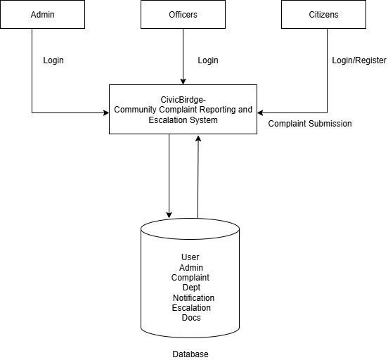

***FIGURE: 5.1 System Architecture***

The system architecture of CivicBridge: Public Complaint Registration and Management System defines the overall structural design and interaction between different components that make up the platform. The architecture is carefully designed to ensure efficiency, modularity, scalability, and data security while providing a seamless experience for all users — citizens, officers, and administrators.

CivicBridge follows a three-tier architectural model, a widely used paradigm for web-based systems. The three layers — Presentation Layer, Application Layer, and Data Layer — are logically separated to enhance system maintainability and scalability. Each layer handles specific tasks and communicates through well-defined interfaces, ensuring smooth data flow and independent scalability.

###### Architectural Overview

The overall architecture is designed to support multiple users simultaneously and to handle realtime complaint submission and tracking. The system consists of three key actors:

* + 1. Citizen/User: Registers and submits complaints, views status updates, and provides feedback after resolution.
    2. Officer: Handles assigned complaints, updates progress, resolves issues, or escalates them to higher authorities.
    3. Administrator: Oversees the entire system, manages user accounts, assigns complaints, monitors escalations, and generates performance reports.

The three-tier architecture allows each actor to interact through the web interface while keeping backend logic and data securely managed on the server side.

###### Architectural Layers

1. Presentation Layer (User Interface Layer)

The Presentation Layer forms the front end of the CivicBridge system, designed using HTML, CSS, and JavaScript to create a responsive and interactive interface.

This layer enables users to:

* + Register and log in securely.
  + Submit complaints with details, images, and locations.
  + View complaint status updates and history.
  + Receive real-time notifications and acknowledgements via email.
  + The interface is designed to be simple and accessible to users with limited technical knowledge, ensuring high usability. Responsive design principles are applied so that the system adapts seamlessly across devices such as desktops, tablets, and mobile phones.

1. Application Layer (Business Logic Layer)

The Application Layer serves as the system’s core, implemented using Python’s Django framework. It acts as the intermediary between the user interface and the database, processing user requests and executing business rules.

This layer handles:

* + User authentication and session management.
  + Complaint submission, categorization, and assignment.
  + Escalation processing when an officer cannot handle a case.
  + Email notifications for registration, updates, and resolution.

This layer follows Django’s Model-View-Template (MVT) architecture, which separates data handling, business logic, and presentation. This modularity ensures that updates or bug fixes in one area do not disrupt others.

1. Data Layer (Database Layer)

The Data Layer is responsible for data storage, retrieval, and integrity management. It uses a MySQL relational database that stores structured data across multiple tables, including:

1. User information
2. Officer details
3. Complaint records and statuses
4. Escalation logs
5. Notifications

Database normalization and indexing techniques are used to minimize redundancy and ensure fast query performance. Django’s ORM (Object Relational Mapper) provides a secure interface for database communication, protecting against SQL injection and unauthorized access.

###### System Workflow

The data flow between the three layers follows this sequence:

1. Input Phase:
   * The citizen submits a complaint via the web interface.
   * Processing Phase:
   * The Django backend validates the input, stores the complaint details, and triggers email notifications.
2. Assignment Phase:
   * The system automatically assigns the complaint to an appropriate officer based on the category or is manually assigned by the admin.
3. Action Phase:
   * The officer reviews, updates, and resolves the complaint or escalates it to higher authorities when necessary.
   * This logical flow ensures traceability, accountability, and transparency throughout the complaint management lifecycle.

###### Architectural Diagram (Description)

The System Architecture Diagram of CivicBridge can be described as follows:

* At the top layer, multiple citizens interact through browsers or mobile devices using the web interface.
* The Application Server (Django Framework) sits in the middle, handling all user requests, authentication, and data processing. It communicates with both the frontend and backend.
* The Database Server (MySQL) forms the base layer, where all complaints, user data, and records are securely stored.
* The Mail Server (SMTP) and Notification Service are auxiliary components that manage alert messages, acknowledgments, and updates.
* The Admin Panel is integrated within the application layer, providing full control for system monitoring and performance evaluation.

This multi-layered structure enables efficient communication between users and officers while maintaining strong separation of responsibilities and high system performance.

###### Security and Communication

To ensure data security and privacy:

* All communication between the client and server uses HTTPS encryption.
* Access control is implemented using role-based permissions.
* File uploads are validated for type and size, stored securely in protected directories.
* Regular database backups and access logging ensure data integrity and recovery in case of failures.
* These measures collectively safeguard user data and maintain trust in the system.

###### Advantages of the System Architecture

Modularity: Each component can be maintained or upgraded independently.

Scalability: Additional users or modules can be accommodated without redesigning the system. Security: Role-based controls and encryption protect user data.

Performance: Clear separation of presentation, business logic, and data access improves efficiency.

Maintainability: The three-tier model simplifies debugging, testing, and future updates.

## CHAPTER 6

### MODULES

The CivicBridge system is designed to provide a comprehensive platform for citizens to submit complaints and for officers to manage them efficiently. The system is divided into six main modules, each serving a specific function to ensure smooth operation, accountability, and transparency.

###### User & Officer Login Module User Login Module:

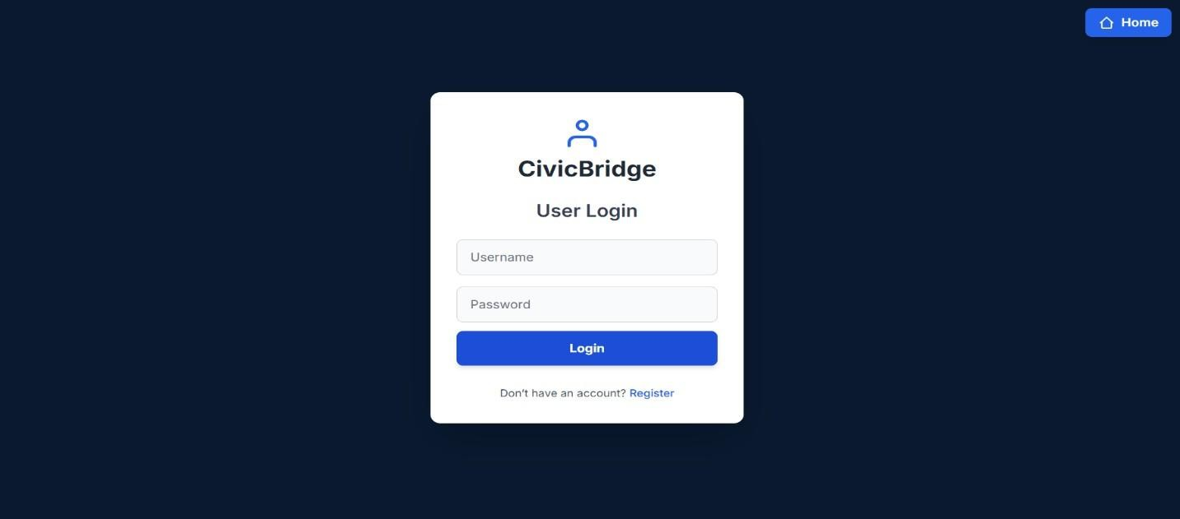The User Login module allows citizens to securely access the CivicBridge platform. Registered users can log in using their credentials to submit new complaints, view complaint status, and receive updates or notifications regarding issue resolutions. This module ensures authorized access and personalized interaction between the user and the system.

***FIGURE:6.1 User Login Module***

###### Officer Login Module:

The Officer Login module enables authorized municipal officers to log in and manage the complaints assigned to them. Through this module, officers can view, update, and resolve public complaints efficiently. It ensures accountability and helps track the progress of civic issues, improving transparency and service delivery.

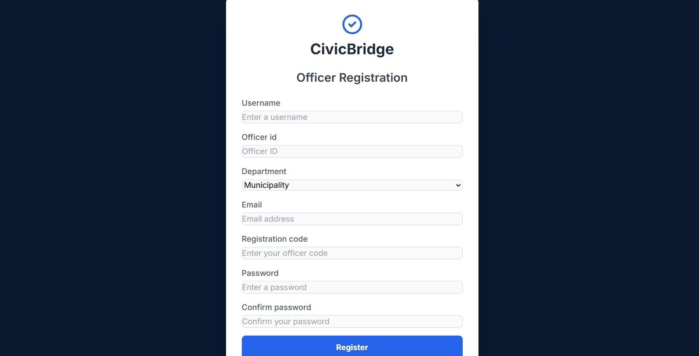

***FIGURE:6.2 Officer Login Module***

###### Complaint Submission Module

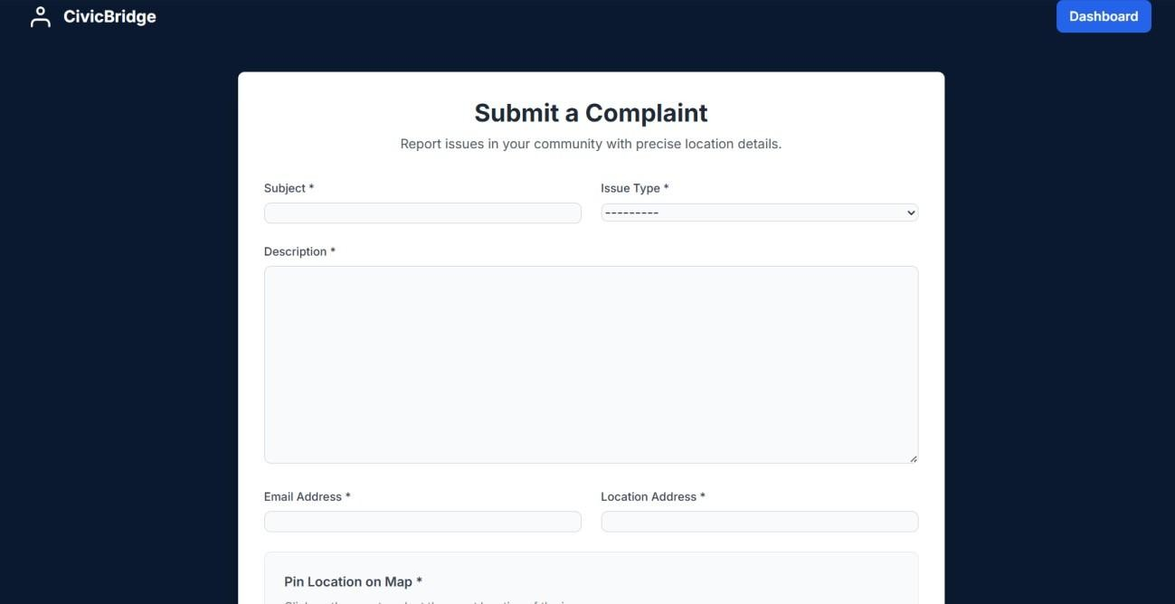The Complaint Submission module allows users to report civic issues such as garbage accumulation, potholes, or streetlight failures through an easy-to-use online form. Users can enter details like location, description, and upload images for better clarity. This module ensures that complaints are recorded accurately and forwarded to the concerned authorities for timely action.

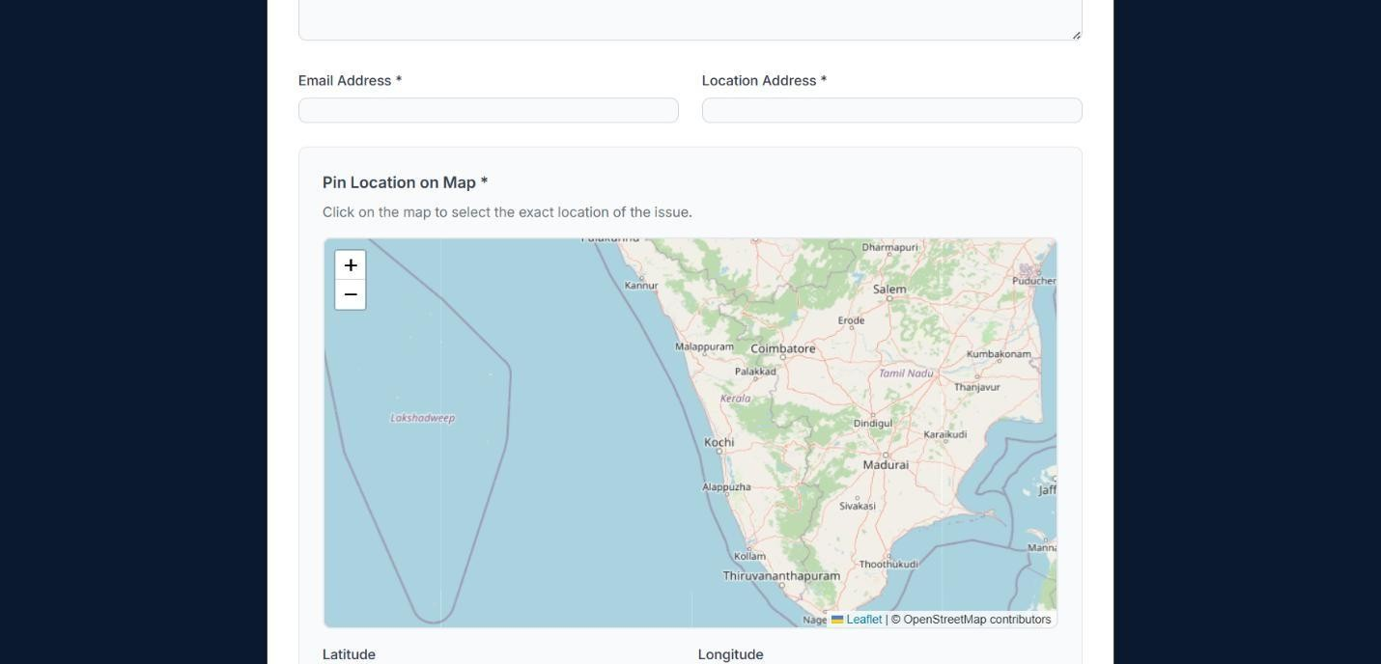

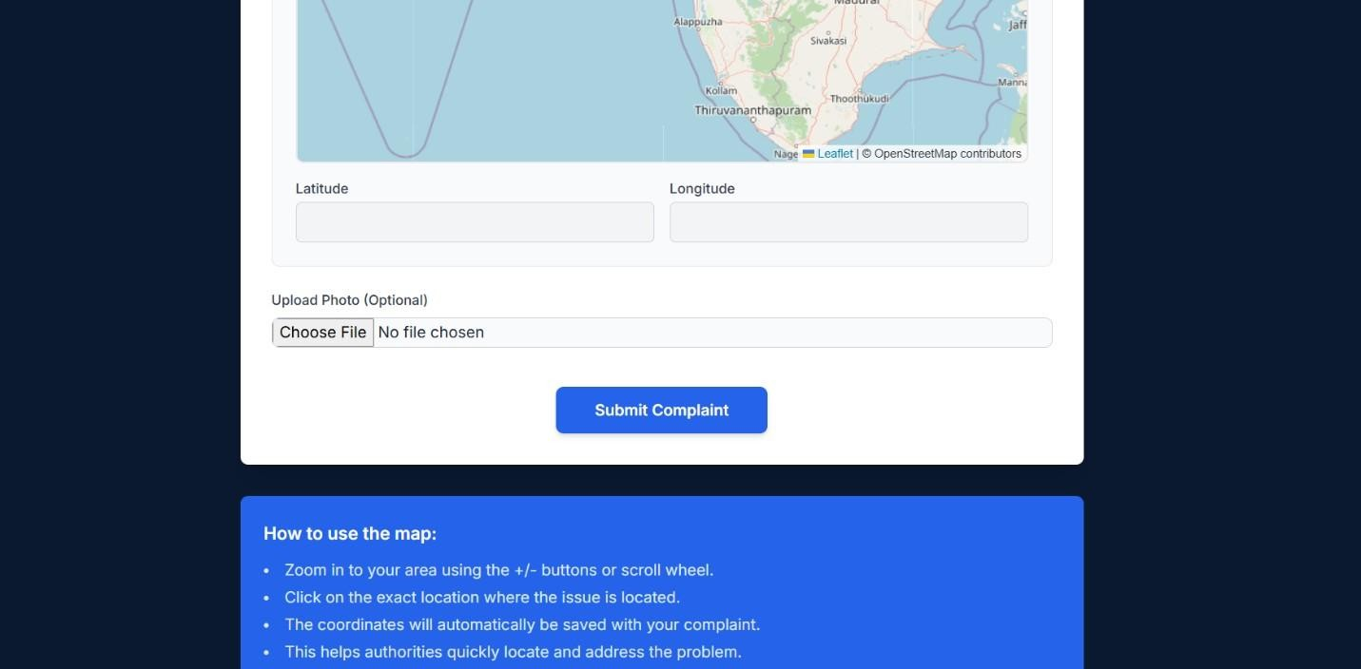

***FIGURE:6.3 Complaint Submission Module***

###### Officer Panel Module

The Officer Panel module provides authorized officers with access to view, manage, and resolve the complaints assigned to them. It enables officers to update the status of each complaint, add remarks, and take necessary actions. This module streamlines the workflow, ensures accountability, and helps maintain efficient communication between citizens and authorities.

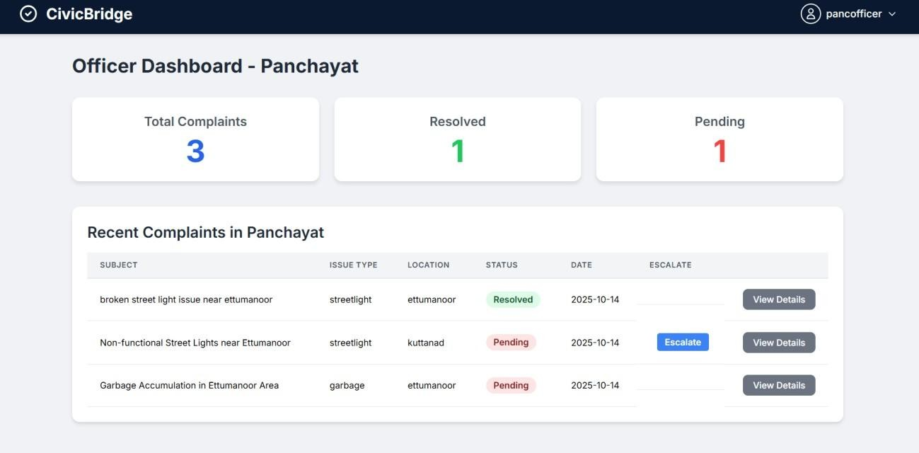

***FIGURE:6.4 Officer Panel Module***

###### Escalation System Module

The Escalation System module allows an officer to escalate a complaint to higher authorities when it cannot be resolved at their level. This ensures that complex or resource-demanding issues receive the necessary attention from senior officials. The module helps maintain a smooth workflow and ensures that every complaint is addressed by the appropriate authority.

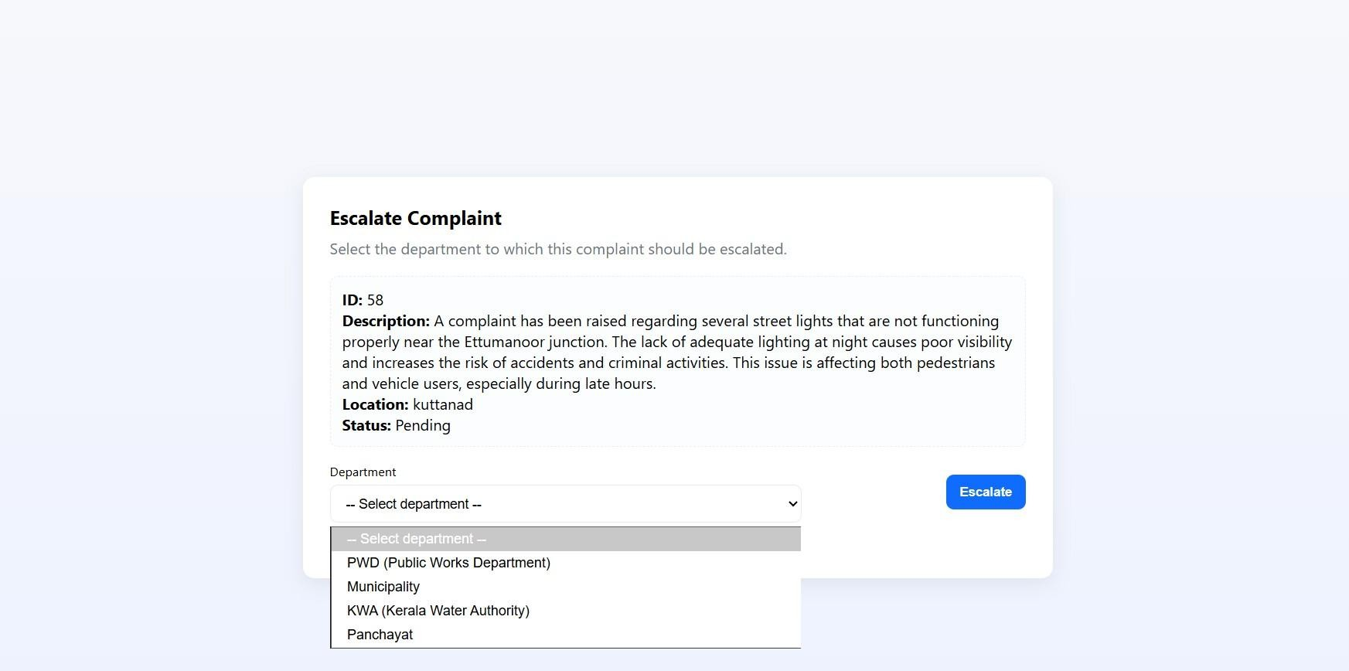

***FIGURE:6.5 Escalation System Module***

###### Notification System Module

The Notification System module ensures effective communication between users and officers throughout the complaint management process. Users receive notifications when a complaint is **registered, updated, escalated, or resolved**, keeping them informed about the progress of their submissions. Similarly, officers are notified of newly assigned complaints or escalations, enabling timely action and maintaining transparency in handling civic issues.

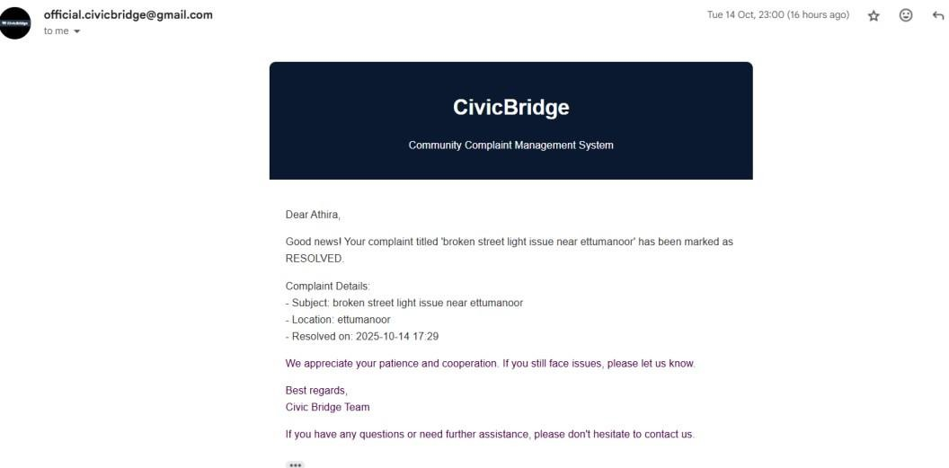

***FIGURE:6.6 Notification System Module***

###### Approve Officer Panel Module

The Officer Approval/Admin module allows the system administrator to manage and approve officer accounts before they can access the CivicBridge platform. This ensures that only authorized personnel are assigned to handle complaints. The module helps maintain system security, accountability, and proper assignment of responsibilities within the complaint management process.

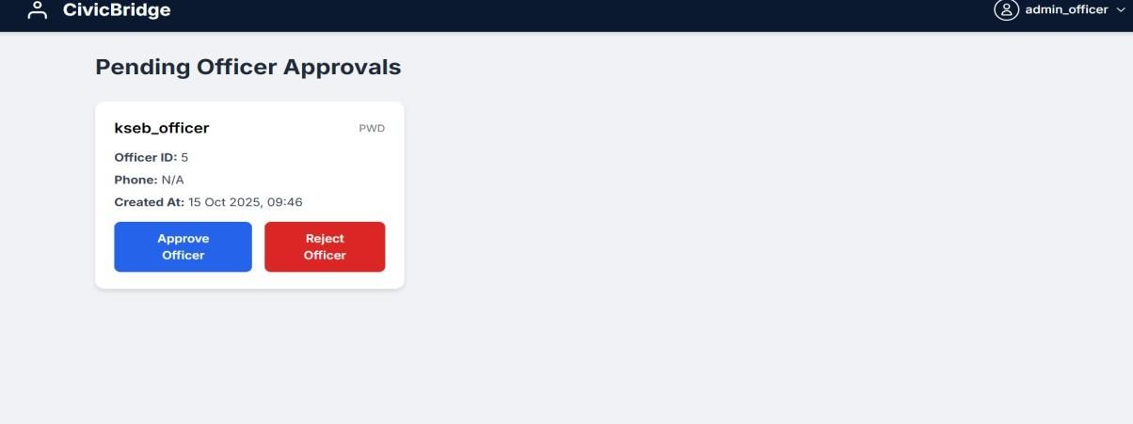

***FIGURE:6.7 Approve officer Panel Module***

## CHAPTER 7

### DIAGRAMS

##### DATA FLOW DIAGRAMS(DFD)

A Data Flow Diagram (DFD) is a graphical representation that illustrates how data moves within a system, showing the flow of information between various processes, data stores, and external entities. It helps in understanding how input data is transformed into output through different processes. DFDs provide a clear and structured way to analyze and design a system’s data processes without delving into technical details like coding or hardware.

In this project, the DFD depicts the movement of data between the user, officer, and system modules. It shows how complaints are submitted by users, processed by the officer panel, and escalated or resolved through different stages of the CivicBridge system. The diagram also highlights interactions with the database for storing and retrieving complaint details, user profiles, and notification data.

By analyzing the DFD, developers and stakeholders can easily understand the logical flow of information in the application, ensuring that all necessary data interactions are properly handled and optimized.

##### LEVEL 0

The Level 0 DFD, also known as the context-level diagram, provides a high-level overview of the *CivicBridge – Community Complaint Reporting and Escalation System*. It illustrates how the system interacts with external entities such as the Admin, Citizen, and Officer. The main process shown in the diagram represents the entire system as a single unit that handles complaint reporting and escalation activities.

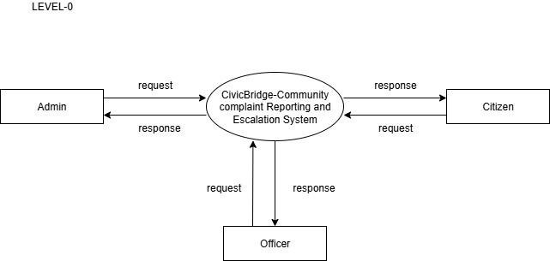

***FIGURE 7.1. Level 0***

###### Citizen:

Citizens are the primary users of the system. They can submit complaints or requests related to civic issues through the system. The system processes these requests and sends responses or updates back to the citizens, such as complaint status or resolution details.

###### Officer:

Officers receive requests or complaints forwarded by the system. They review, investigate, and take appropriate actions to resolve the issues. Once the action is completed, they send responses or status updates back to the system, which are then reflected to the concerned citizen.

###### Admin:

The admin is responsible for managing and monitoring the entire system. The admin handles tasks such as approving officer accounts, managing user data, and overseeing complaint resolution activities. The admin sends requests to the system for management operations and receives system-generated responses like reports or status summaries.

##### LEVEL 1 ADMIN

The Level 1 DFD for the Admin provides a detailed breakdown of the processes handled by the administrator within the *CivicBridge System*. It shows how the admin interacts with different subsystems for managing users, officers, and departments. The main processes include login authentication, user management, officer management, and department management.

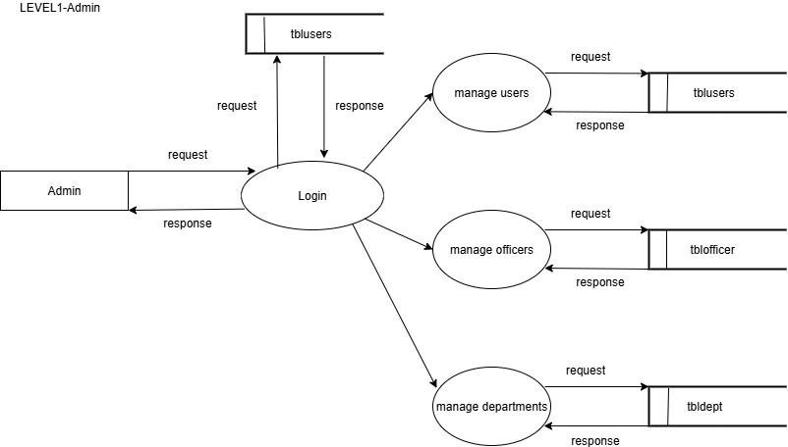

***FIGURE:7.2 Level 1 Admin***

###### Admin Login:

The admin initiates the process by logging into the system. The login request is verified by checking the admin’s credentials in the database. Upon successful authentication, the admin gains access to the system’s control panel. The login process ensures only authorized personnel can access the administrative functionalities.

###### Manage Users:

Once logged in, the admin can view, add, edit, or delete user details. This process interacts with the tblusers database table, which stores all user-related information. When the admin performs any action, corresponding requests and responses are exchanged with the table to update or retrieve data.

###### Manage Officers:

This process allows the admin to manage the list of officers who handle user complaints. The admin can approve new officers, update their details, or remove inactive ones. The data is stored and maintained in the tblofficer table, ensuring that only verified officers are part of the complaint resolution process.

###### Manage Departments:

The admin also manages different departments responsible for handling specific types of complaints (e.g., water, electricity, waste management). The process interacts with the tbldept table, where all department details are stored. The admin can add new departments, modify existing ones, or delete obsolete entries.

##### LEVEL 1 CITIZEN

The Level 1 DFD for the Citizen describes how the system manages user interactions for complaint reporting and communication. It focuses on the citizen’s activities, including registration, complaint submission, receiving notifications, and checking complaint status. This diagram shows the flow of data between the citizen, the system processes, and the database table tblusers.

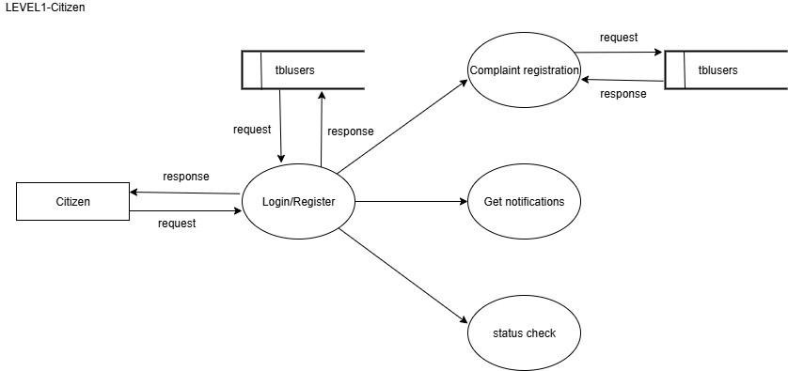

***FIGURE:7.3 Level 1 Citizen***

###### Login/Register:

Citizens begin by either registering as new users or logging into their existing accounts.

* + During registration, user details such as name, contact information, and login credentials are stored in the tblusers database.
  + During login, the system validates the entered credentials against the stored data and grants access if they are correct.

This ensures secure and personalized access to the complaint management features.

###### Complaint Registration:

After logging in, citizens can register new complaints regarding civic issues such as sanitation, streetlights, or water supply. The system records the complaint details—like complaint type, description, and location—into the tblusers (or linked complaint) table.

The system then sends a confirmation or acknowledgment response back to the citizen.

###### Get Notifications:

This process enables citizens to receive updates and alerts about the status of their complaints. Notifications may include acknowledgments from officers, progress reports, or resolution messages. These updates ensure transparent communication between citizens and authorities.

###### Status Check:

Citizens can check the current status of their submitted complaints. The system retrieves the relevant information from the database and displays it to the citizen, showing whether the complaint is pending, in progress, or resolved.

##### LEVEL1 OFFICER

The Level 1 DFD for the Officer illustrates how officers interact with the system to manage and resolve citizen complaints. It explains the detailed data flow between the Officer, various system processes, and the related database tables such as tblofficer, tblcomplaints, and tbldept.

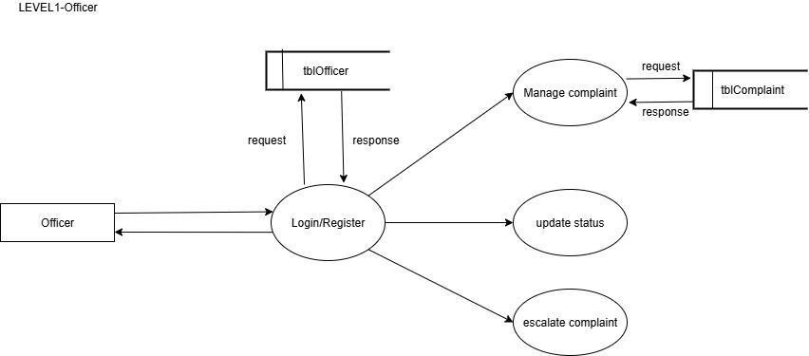

***FIGURE:7.4 Level 1 Officer***

###### Login/Authentication:

Officers start by logging into the system using their authorized credentials.

* + The system validates the entered username and password with the data stored in the tblofficer table.
  + Once verified, the officer gains access to their dashboard, which provides tools for complaint management and status updates.

This ensures that only verified officers can handle and update complaint information.

###### View Assigned Complaints:

After successful login, the officer can view all complaints assigned to their department or under their supervision.

* + The system fetches complaint data from the tblcomplaints table.
  + Officers can filter or prioritize complaints based on urgency or submission date. This process helps in organizing work efficiently and responding quickly to citizen concerns.

###### Update Complaint Status / Provide Resolution:

Once an officer takes action on a complaint, they update the status (e.g., *In Progress*, *Resolved*, or *Escalated*).

* + The updated information is stored back into the tblcomplaints table.
  + The system automatically triggers notifications to inform the concerned citizen about the progress or resolution.

This maintains transparency and accountability in complaint handling.

###### View Notifications / Escalations:

Officers receive notifications from the admin or automated escalation system regarding overdue or high-priority complaints.

* + These alerts ensure that no issue remains unattended beyond a predefined time frame.
  + The officer can take immediate corrective action and update the system accordingly.

##### USE CASE DIAGRAM

A use case diagram is a visual tool from the Unified Modeling Language (UML) that illustrates a system's functionality from a high-level, user-centric perspective. It identifies the external users (actors) and the specific actions (use cases) they can perform, effectively mapping out the scope of a system's features. The diagram for the CivicBridge system exemplifies this by defining three actors and their interactions with a civic complaints platform. It shows the Citizen, who can submit a complaint and receive notifications; the Officer, who is authorized to manage complaints and escalate them; and the Admin, who handles system-level tasks like managing users and approving officers. This model clearly outlines the entire workflow, from a complaint's submission by the public to its resolution by verified officials, all within a secure and administratively controlled environment.

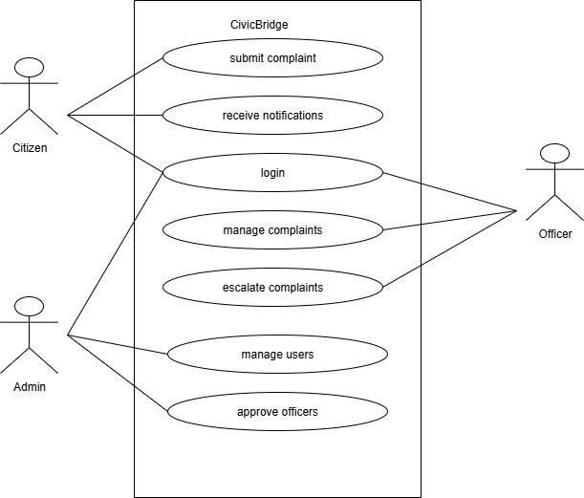

***FIGURE:7.5 Use case Diagram***

##### STATE DIAGRAM

This State Machine Diagram models the life cycle of a single Complaint object within the CivicBridge system, beginning at the initial state and concluding at the final state. The process starts in the **New complaint** state and transitions via the *submit* event to **Assigned to officer**, subsequently moving to **In progress** when an official begins work. From the *In progress* state, the flow branches: the complaint can either move directly to **resolved** or be transitioned to **esclated** if it requires intervention from a higher authority. Critically, an escalated complaint can transition back to the **resolved** state via the *higher authority* event, illustrating a critical feedback loop for complex issues. Finally, the successfully **resolved** complaint transitions to the **closed** state, signifying the termination of its life cycle within the system.

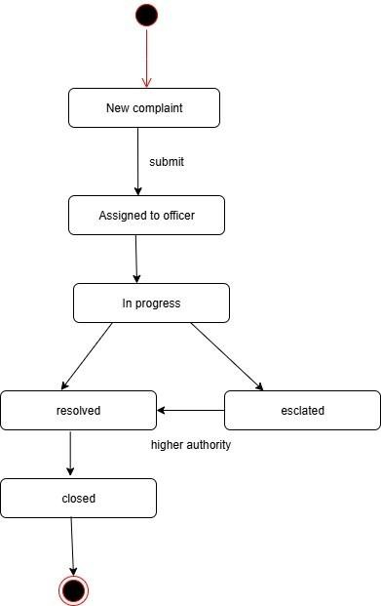

***FIGURE:7.6 State Diagram***

##### ENTITY-RELATIONSHIP DIAGRAM(ER)

The ER Diagram represents the data and relationships within the CivicBridge system, showing how different entities interact. Key entities include User, Officer, Admin, Complaint, Notification, and Escalation.

* User submits complaints; Officer handles them; Admin approves officers.
* Complaint stores details like type, description, and status.
* Notification tracks updates for users and officers, while Escalation manages complaints forwarded to higher authorities.

The relationships, such as a user submitting multiple complaints or a complaint generating multiple notifications, ensure data consistency and proper database design, serving as a blueprint for implementing the system efficiently.

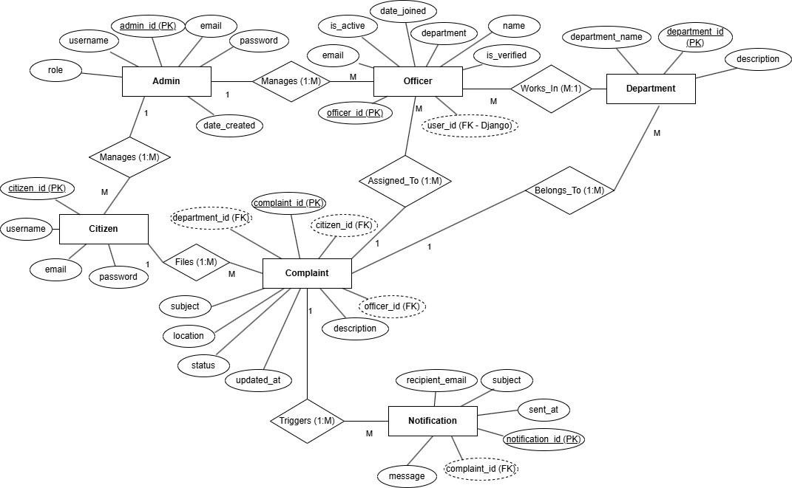

***FIGURE****:7.7* ***ER Diagram***

##### CLASS DIAGRAM

The Class Diagram represents the structure of the CivicBridge system by showing its classes, attributes, and the relationships between them. Key classes include User, Officer, Admin, Complaint, Notification, and Escalation.

* The User class contains attributes like user ID, name, and contact details and methods to submit complaints.
* The Officer class includes officer ID, name, and department, with methods to manage and update complaints.
* The Admin class manages officer approvals and overall system control.
* The Complaint class stores details such as complaint ID, type, description, location, and status.
* The Notification class tracks updates sent to users and officers, while the Escalation class handles complaints forwarded to higher authorities.

This diagram provides a clear view of the system’s design, showing how objects interact and ensuring a well-structured, maintainable, and efficient implementation.

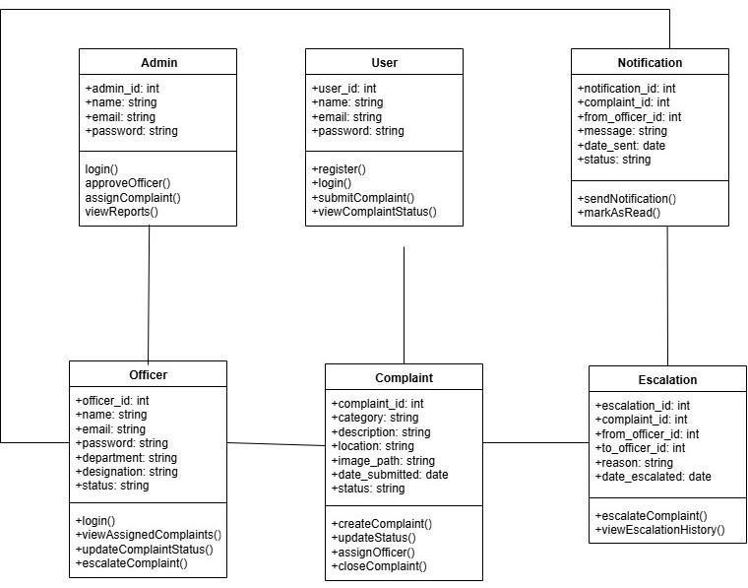

***FIGURE:7.8 Class Diagram***

## CHAPTER 8

### TESTING

Testing is a **crucial phase** in the CivicBridge project to ensure that the system performs efficiently, reliably, and securely under real-world conditions. The main objective of testing is to verify that all modules function as intended, complaints are processed correctly, notifications are delivered promptly, and escalations occur smoothly when required. This chapter provides a comprehensive explanation of the **complete testing process** employed for the CivicBridge system, emphasizing its **functional, performance, security, and usability aspects**.

###### Data Collection and Preparation

The first step in testing involves **collecting and preparing a realistic dataset** that simulates actual usage of the CivicBridge system. A diverse dataset is essential to assess the system’s response to different scenarios and to identify potential bottlenecks or failure points. The dataset includes:

* + - **Citizen data:** Names, ages, genders, addresses, geolocation, and contact details to simulate real users.
    - **Complaint data:** Covers a wide range of civic issues such as sanitation problems, traffic congestion, public infrastructure repairs, street lighting, and safety concerns. Each complaint is given a **unique identifier** for easy tracking.
    - **Officer data:** Information about roles, assigned areas, access levels, and departments to replicate administrative workflows accurately.
    - The data is carefully **verified for accuracy and completeness**. Additionally, several testing scenarios are created, including:
    - **Normal cases:** Standard complaints submitted with all required details.
    - **Edge cases:** Situations such as incomplete forms, invalid location information, or missing attachments.
    - **Extreme cases:** Duplicate complaints, high complaint volumes, or complaints requiring immediate escalation.

This thorough preparation ensures that the system is tested against **diverse real-world situations**, allowing developers to identify weaknesses and optimize performance.

###### Functional Testing

Functional testing ensures that **each module and feature operates according to specifications**. Key aspects of functional testing include:

###### Login and Authentication Module:

* + Tested with valid and invalid credentials to ensure secure access.
  + Role-based access control (RBAC) is verified to ensure that citizens, officers, and administrators can only access functionalities assigned to their roles.

###### Complaint Submission Module:

* + Ensures that citizens can submit complaints with all required details.
  + Validates attachments such as images or documents, and confirms that unique complaint IDs are generated correctly.

###### Officer Panel Module:

* + Allows officers to review assigned complaints, update progress, and mark complaints as **In Progress, Resolved, or Escalated**.
  + Tests proper tracking and status updates for each complaint.

###### Escalation System:

* + Simulates situations where officers are unable to resolve complaints, confirming that these complaints are **escalated to higher officers** and that the system retains complete history for transparency.

###### Notification System:

* + Ensures that **email and in-app notifications** are triggered correctly for submission, updates, escalations, and resolution of complaints.
  + Tests multiple notification scenarios simultaneously to validate system reliability.

###### Officer Approval Module:

* + Verifies that administrators can approve, reject, or deactivate officer accounts.
  + Ensures role management and access rights are correctly enforced.
  + Through functional testing, all features are thoroughly validated to ensure smooth system operation and a positive user experience.

###### Performance and Load Testing

Performance testing evaluates whether CivicBridge can handle **simultaneous interactions and high loads** without degradation in system response. Key areas include:

* + - Simulating **multiple citizens submitting complaints at the same time**, testing the system’s ability to process requests efficiently.
    - Ensuring officers can manage **large volumes of complaints concurrently**, including updates, status changes, and escalations.
    - Measuring **response times** for complaint submission, status updates, escalations, and notifications.

The system is expected to maintain **consistent and fast performance** under both normal and peak loads, ensuring reliability in real-world operations. Performance metrics are recorded and analyzed to optimize system efficiency and scalability.

###### Security and Privacy Testing

Security and privacy are critical for CivicBridge, as the system manages **sensitive citizen and officer data**. Security testing involves:

* + - Verifying **authentication mechanisms** to prevent unauthorized access.
    - Ensuring **confidential storage and transmission** of sensitive information, including personal details of citizens and officers.
    - Testing input validation to protect against **malicious data submissions**, including SQL injection and XSS attacks.
    - Confirming that **notifications do not expose sensitive information**, maintaining compliance with data protection regulations.
    - These tests ensure that CivicBridge is secure, protecting both system integrity and user privacy.

###### User Acceptance Testing (UAT)

User Acceptance Testing is conducted with **actual users and municipal staff** to verify that the system meets user requirements and expectations:

* + - Citizens submit complaints, track progress, and receive notifications.
    - Officers manage assigned complaints and escalate when necessary.
    - Administrators approve officers, monitor activity, and generate reports.

Feedback from UAT is used to refine the system, **improve usability**, and correct any remaining issues. UAT ensures that CivicBridge is **intuitive, user-friendly, and practical for real-world use**, confirming that the system fulfills its intended purpose.

###### Issue Tracking and Resolution

During the testing phase, all **bugs, errors, or issues** are systematically logged with:

* + - Detailed descriptions of the problem.
    - Severity ratings to prioritize critical issues.
    - Steps to reproduce each issue.

Issues are assigned to developers for resolution and **retested** to confirm fixes. This structured approach ensures that the system is stable, reliable, and ready for deployment.

###### Deployment and Monitoring Testing

Before full deployment, CivicBridge is tested in a **simulated live environment**:

* + - Email notifications are checked for accuracy and timely delivery.
    - Multiple users access the system concurrently to validate **smooth operations under real- world conditions**.
    - Monitoring mechanisms are tested to detect and log issues such as slow responses, failed notifications, or escalation errors.

This ensures that CivicBridge performs reliably after deployment, providing **continuous monitoring**

for potential operational issues.

###### Conclusion

Through comprehensive testing, CivicBridge is validated as a **reliable, secure, and user-friendly platform** for civic complaint management. Key outcomes of the testing process include:

* + - **Functional testing:** Confirms that all modules work correctly and complaints are properly processed.
    - **Performance testing:** Ensures the system operates efficiently under high load and multiple concurrent users.
    - **Security testing:** Protects sensitive data and maintains system integrity.
    - **User Acceptance Testing (UAT):** Confirms the system meets user expectations and is practical for real-world applications.
    - **Issue tracking and deployment testing:** Guarantees system robustness, reliability, and operational readiness.

Overall, these testing procedures ensure that CivicBridge can be confidently deployed to **enhance accountability, transparency, and citizen satisfaction**, providing a modern, digital solution to streamline civic grievance management. The system is now capable of bridging the gap between citizens and municipal authorities, transforming complaint handling from a **manual and inefficient process** into an **efficient, secure, and data-driven digital ecosystem**.

## CHAPTER 9

### ADVANTAGES AND DISADVANTAGES

###### Advantages

1. **Improved Efficiency:**

CivicBridge automates the complaint submission and tracking process, reducing manual paperwork and ensuring faster processing of complaints. Citizens can submit complaints online, and officers can manage them systematically, improving overall efficiency in civic administration.

###### Transparency and Accountability:

The system provides complete visibility of the complaint lifecycle, from submission to resolution. Citizens can track the status of their complaints in real time, and officers’ actions are recorded, ensuring accountability at every level.

###### Effective Escalation Mechanism:

Complaints that cannot be handled by assigned officers are escalated to senior officers, ensuring that no complaint is left unresolved and all issues receive proper attention.

###### Notification System:

Email notifications keep citizens and officers informed about complaint updates, escalations, and resolutions, enhancing communication and reducing the need for manual follow-ups.

###### Secure Access and Role Management:

Role-based access ensures that users and officers can only perform actions appropriate to their roles. Administrators can approve, manage, or deactivate officer accounts, ensuring system security and integrity.

###### Centralized Complaint Management:

All complaints, officer activities, and updates are maintained in a centralized system, enabling better monitoring, reporting, and decision-making for civic authorities.

###### User-Friendly Interface:

The platform is designed to be intuitive and easy to use for citizens, officers, and administrators, promoting widespread adoption and smooth operation.

###### Disadvantages

1. **Dependence on Internet and Devices:**

CivicBridge is an online platform, so citizens and officers must have reliable internet access and compatible devices to use the system effectively.

###### Email-Only Notifications:

The system sends notifications exclusively via email, which may not reach users promptly if they do not regularly check their email. SMS or app-based notifications could improve responsiveness.

###### Data Privacy Concerns:

Although security measures are in place, storing sensitive user and officer data digitally always carries potential risks of unauthorized access or data breaches.

###### Technical Limitations:

Users unfamiliar with digital platforms may face difficulties submitting complaints or navigating the system, potentially limiting accessibility for some citizens.

###### Escalation Dependency:

The system relies on officers to escalate complaints they cannot handle. If officers fail to escalate, certain complaints may face delays in resolution.

###### Maintenance and Updates:

Like all software systems, CivicBridge requires regular maintenance, monitoring, and updates to fix bugs, improve performance, and adapt to evolving civic needs. This may require dedicated technical resources.

## CHAPTER 10

### RESULTS

The result analysis of the CivicBridge project evaluates how effectively the system meets its objectives, including complaint registration, officer management, escalation handling, and notification delivery. This chapter highlights the observed outcomes, system performance, and overall effectiveness after testing and deployment. Screenshots from the system can be added alongside each section to provide visual evidence of functionality.

###### Complaint Submission Analysis

The complaint submission module was tested with a variety of complaint types, including sanitation, traffic, public infrastructure, and safety issues. The system successfully registered complaints with unique IDs, captured all required details, and stored attachments accurately. Citizens were able to track the status of their complaints in real time.

Observations:

* + - All submitted complaints were visible in the officer panel immediately after submission.
    - System validation prevented incomplete complaints from being submitted.
    - Attachments, including images and documents, were stored and retrieved correctly.

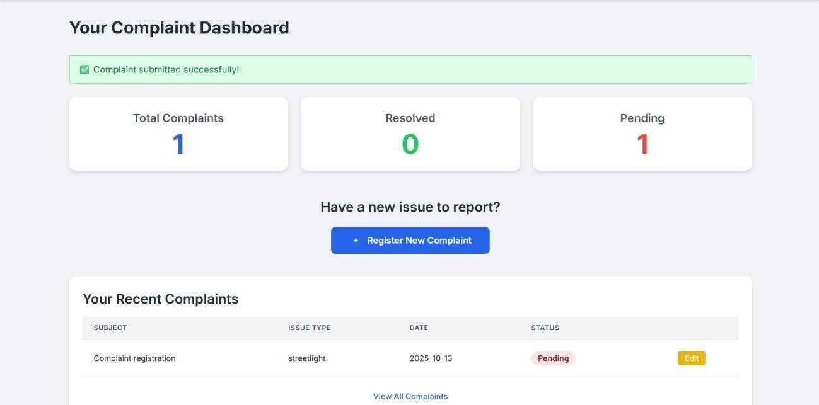

***FIGURE:10.1 User Dashboard***

###### Officer Panel Analysis

The officer panel was evaluated for handling complaints assigned to different officers. The module allowed officers to update complaint status, add remarks, and resolve complaints efficiently.

Observations:

* + - Officers could view all complaints assigned to them with complete details.
    - Status updates were reflected in real time on both the citizen dashboard and notifications.
    - Notes and remarks added by officers were stored accurately and were visible to other relevant authorities.

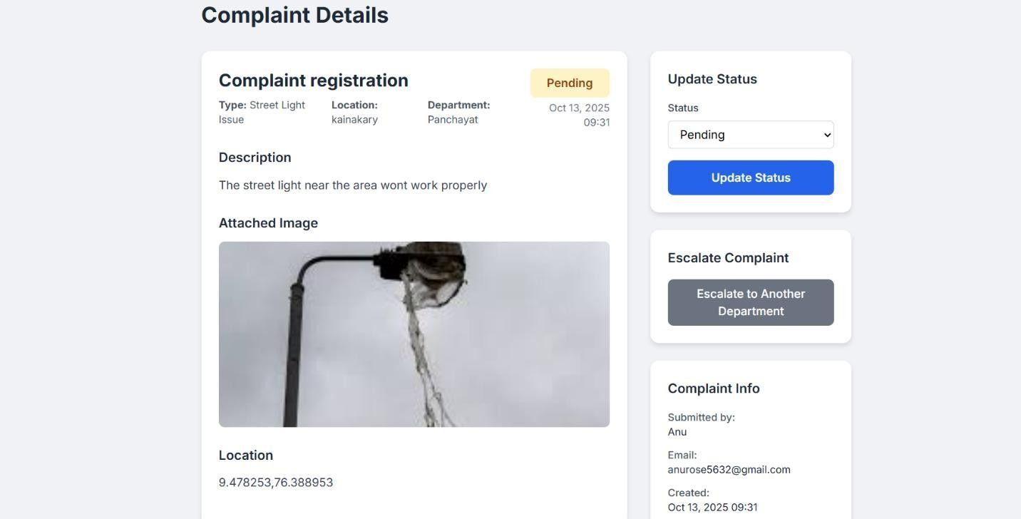

***FIGURE:10.2 Officer Panel Analysis***

###### Escalation System Analysis

The escalation system was tested by simulating complaints that could not be handled by the assigned officer.

Observations:

* + - Complaints flagged for escalation were successfully transferred to senior officers.
    - The system maintained a record of the escalation, ensuring accountability.
    - Senior officers were able to take necessary action and update the complaint status.

###### Notification System Analysis

The notification system was evaluated for effectiveness in sending email updates to citizens and officers.

Observations:

* + - Email notifications were sent immediately after complaint submission, updates, or escalation.
    - Emails contained accurate details about the complaint and current status.
    - Users confirmed receiving timely notifications for all relevant actions.

###### System Performance and Reliability Analysis

The overall system performance was assessed by simulating multiple users submitting complaints simultaneously and officers managing complaints.

Observations:

* + - The system handled concurrent submissions efficiently without delays or errors.
    - Response time for complaint registration, updates, and escalations remained within acceptable limits.
    - No crashes or unexpected behaviors were observed during testing.

###### Conclusion

The results from testing CivicBridge demonstrate that the system effectively meets its objectives. Citizens are able to submit and track complaints easily, officers can manage and escalate complaints efficiently, and email notifications ensure timely communication. Performance testing confirms that the system can handle multiple users simultaneously without performance degradation.

The screenshots provide clear evidence of system functionality and successful execution of all modules. Overall, CivicBridge proves to be a reliable, user-friendly, and efficient platform for civic complaint management.

## CHAPTER 11

### CONCLUSION & FUTURE SCOPE

##### CONCLUSION

The CivicBridge project successfully demonstrates the development of a comprehensive, user- friendly platform for managing civic complaints efficiently and transparently. The system integrates multiple functionalities, including complaint submission, officer management, escalation handling, and notification delivery, to provide a structured and accountable framework for citizen-government interaction.

Throughout the development and testing phases, CivicBridge proved capable of handling a variety of real-world scenarios. Citizens were able to submit complaints easily, track their status in real time, and receive timely notifications via email. Officers were able to manage and update complaints efficiently, and the escalation mechanism ensured that unresolved issues were promptly addressed by senior authorities. Testing confirmed that the system performs reliably under normal and peak load conditions, and all modules functioned as intended, demonstrating robustness and scalability.

The advantages of CivicBridge, such as improved efficiency, transparency, accountability, centralized complaint management, and a user-friendly interface, outweigh the minor limitations, including dependence on internet access and email-based notifications. These limitations can be mitigated with future enhancements, such as mobile app notifications, SMS alerts, multilingual support, and additional user guidance or training.

In conclusion, CivicBridge is an effective solution that bridges the gap between citizens and civic authorities, enhances the accountability of public service management, and ensures faster resolution of complaints. The system’s reliability, structured workflow, and intuitive interface make it a valuable tool for improving citizen satisfaction and promoting responsive governance. Moreover, the platform lays the foundation for integrating advanced technologies in the future, such as GIS mapping of complaint hotspots, AI-assisted complaint prioritization, and automated performance analytics, which can further enhance operational efficiency. With these potential enhancements, CivicBridge can evolve into a more advanced, widely adopted platform, contributing significantly to smart civic management, efficient public administration, and a stronger participatory approach to governance.

##### FUTURE SCOPE

The CivicBridge project has successfully demonstrated a structured and efficient platform for civic complaint management. However, there is significant potential to further enhance the system and expand its functionalities to better serve citizens and authorities.

One major area of improvement is multi-channel notifications. Currently, notifications are sent only via email. Future versions could integrate SMS alerts, mobile app push notifications, or WhatsApp messages to ensure real-time updates reach all users promptly.

The system could also be enhanced with mobile application support, making it more accessible to citizens who rely on smartphones. A dedicated mobile app would allow users to submit complaints on-the-go, upload images instantly, and track status conveniently.

Another potential enhancement is advanced analytics and reporting. By analyzing complaint data over time, CivicBridge could provide insights into recurring civic issues, identify high- priority areas, and assist authorities in resource planning and decision-making. Predictive analysis could also help proactively address issues before they escalate.

Integration with other government services could make CivicBridge a more comprehensive civic management platform. Linking with public service databases, urban planning departments, or emergency services would allow authorities to respond more efficiently to complaints and provide a more coordinated approach to civic management.

Enhanced security and privacy measures can be implemented in future iterations, including encryption improvements, multi-factor authentication, and compliance with global data protection regulations, ensuring that citizens’ personal information is fully safeguarded.

Finally, AI-driven features could be added to automatically categorize complaints, prioritize urgent cases, or suggest optimal solutions to officers, further improving efficiency and reducing resolution times.

In conclusion, the CivicBridge platform has strong potential for continuous improvement and scalability. By adopting modern technologies, expanding accessibility, and integrating analytics, CivicBridge can evolve into a fully intelligent, citizen-centric system for smart and responsive civic administration.

## APPENDICES

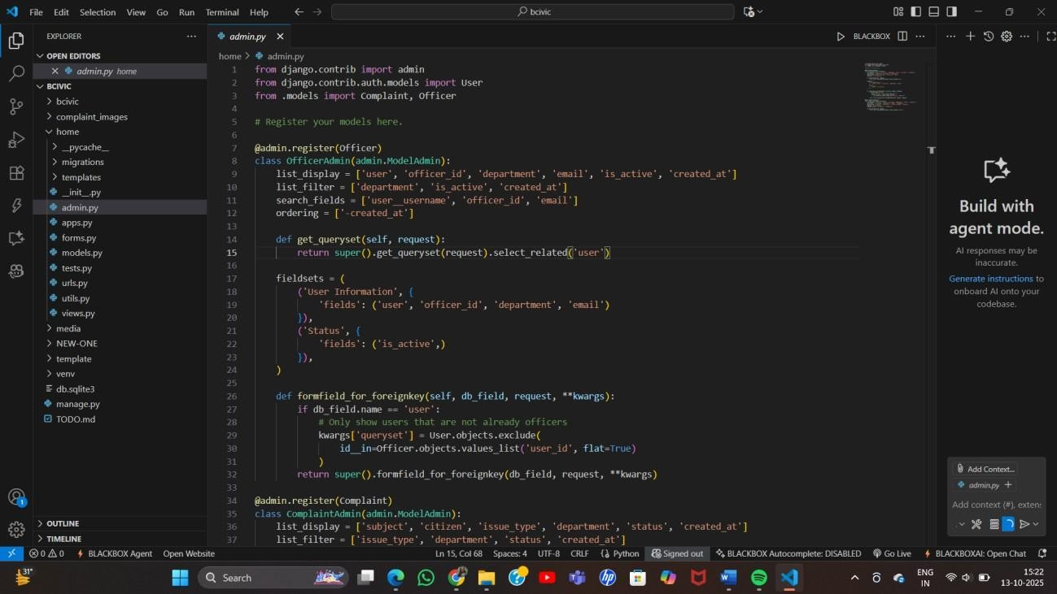

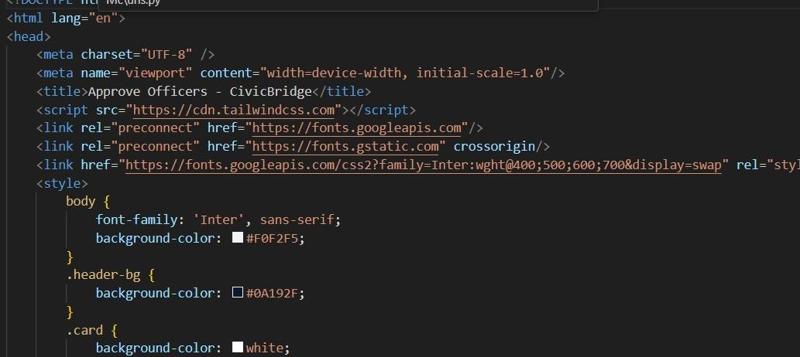

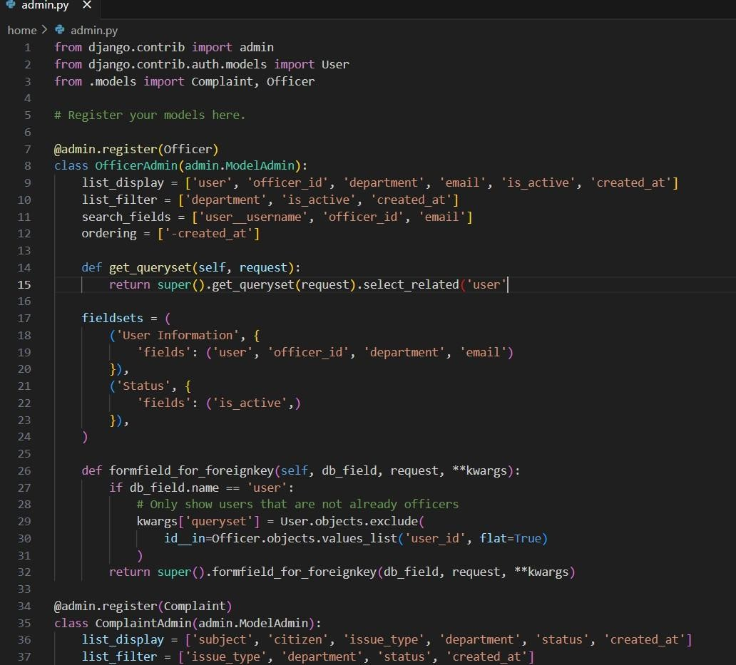

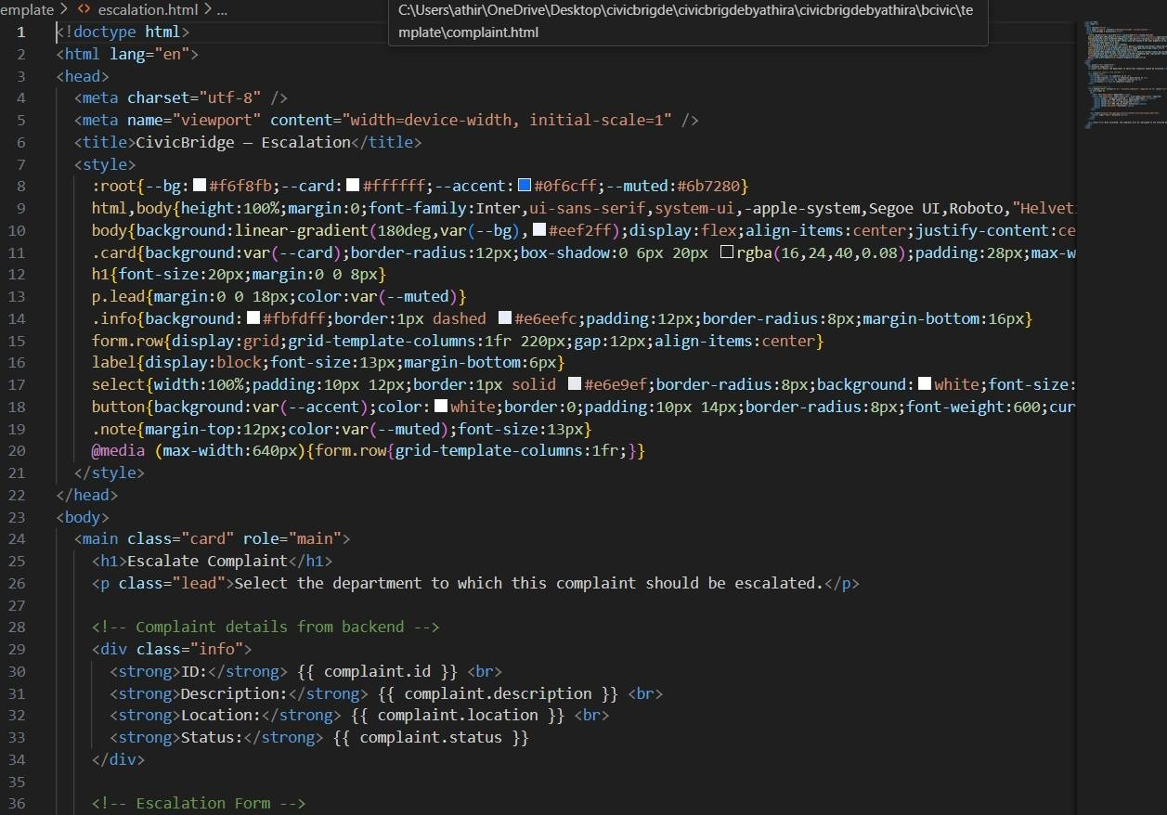

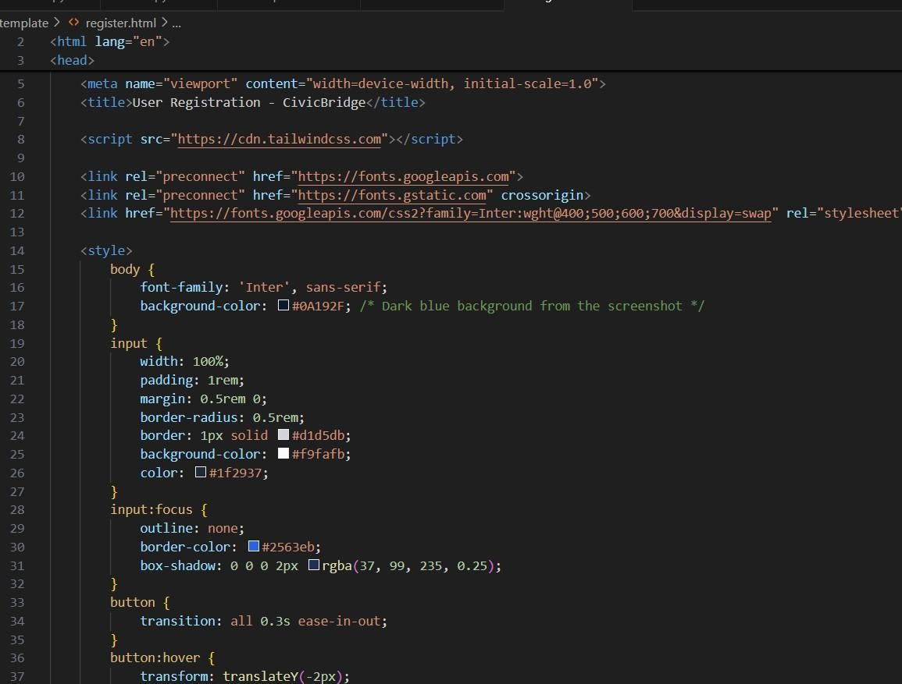

## REFERENCES

1. D. Hiremath, H. Patil, R. Patil, V. Hiremath, and C. R. Shivanagi, "Public Online Complaint Registration and Management System," 2024.
2. U. N. Tripathi et al., "iGRAM: Online Grievance Redressal at IGNOU," NCERT, 2021.
3. C. Venkatesh et al., "RE-GrievanceAssist," *arXiv*, 2024.
4. V. Mutiawani et al., "Web-Based Complaint System," *International Journal of Software Engineering and Computer Science (IJSECS)*, 2024.
5. M. Heriyanto et al., "Online Community Aspiration Services," *Publik*, 2022.
6. S. Sinha and R. Sonawane, "Blockchain & AI Grievance System," *ResearchGate*, 2022.
7. ResearchGate, "Complaint Registration App for E-Governance," 2025.
8. ResearchGate, "Web-Based Integrated Student Complaint System," 2023.
9. ResearchGate, "Complaint Monitoring System Using Android in Iraq," 2024.
10. ResearchGate, "Web-Based Complaints Service Information System at Dewantara District Office," 2025.
11. P. Priyadharshini and P. Rajalakshmi, "Municipal Corporation Complaint Management System Using Web," *Semantic Scholar*, 2018.
12. B. Sudhir and S. Suresh, "India Electronic Complaint Management System for Municipal Corporation," *Communications on Applied Electronics (CAE)*, vol. 2, no. 8, pp. 1-5, 2015.
13. D. Hiremath, H. Patil, R. Patil, V. Hiremath, and C. R. Shivanagi, "Public Online Complaint Registration and Management System," *International Journal of Scientific Development and Research (IJSDR)*, vol. 9, no. 3, pp. 958-962, Mar. 2024.
14. R. M. Gandhi and S. Hemalatha, "An Efficient Complaint Management System for Urban Local Bodies," *International Journal of Advanced Research in Computer Science*, vol. 10, no. 2, 2019.
15. Y. Kumar and S. Sharma, "Design and Implementation of Municipal Complaint Management System," *International Journal of Computer Applications*, vol. 175, no. 6, 2020.
16. P. Singh and R. Gupta, "Smart City Complaint Monitoring System," *International Journal of Computer Science and Mobile Computing*, vol. 8, no. 5, pp. 23-30, 2019.
17. M. H. Rizvi and A. K. Singh, "Web-based Grievance Redressal System for Local Governments," *International Journal of Computer Applications*, vol. 182, no. 3, 2019.
18. L. T. Nguyen and H. T. Le, "Mobile-based Complaint Management Application for Municipal Services," *International Journal of Engineering Research & Technology*, vol. 9, no. 7, 2020.
19. A. Sharma and V. K. Bansal, "Citizen Complaint Management System Using Cloud Technology," *International Journal of Scientific Research in Science and Technology*, vol. 8, no. 4, pp. 112-118, 2021.
20. R. Patel and K. Mehta, "Smart Grievance Management System for E-Governance,"

*International Journal of Emerging Technology and Advanced Engineering*, vol. 11, no. 9, 2021.

**Athira Anil**

# MINI PROJECT REPORT-Athira Anil

 MINIPROJECT REPORT PLAGARISM CHECKING

Document Details

Submission ID trn:oid:::10159:117211192

59 Pages

11,502 Words

73,501 Characters

Submission Date

Oct 17, 2025, 9:37 PM GMT+5:30

Download Date

Oct 17, 2025, 9:39 PM GMT+5:30

File Name

MINI PROJECT REPORT1-content only.pdf

File Size

2.0 MB

# 16% Overall Similarity

The combined total of all matches, including overlapping sources, for each database.

Match Groups

 136Not Cited or Quoted 15%

Matches with neither in-text citation nor quotation marks

0 Missing Quotations 0%



Matches that are still very similar to source material

 10 Missing Citation 1%

Matches that have quotation marks, but no in-text citation

0 Cited and Quoted 0%



Matches with in-text citation present, but no quotation marks

Top Sources

|  |  |
| --- | --- |
| 6% | Internet sources |
| 5% | Publications |
| 13% | Submitted works (Student Papers) |